**TRANSPORT AND TELECOMMUNICATION INSTITUTE**



<<FACULTY NAME HERE>>

**COURSE WORK**

Object-Oriented Programming

Topic: «Static Website Development»

Performed by:

Student: XXXXXXXXXXXXXXXXXX

Group: XXXXXXX

Student code: XXXXXXX

Riga

2022

# TABLE OF CONTENTS

INTRODUCTION 2

TASK FOR LABORATORY WORK 3

ANALYSIS OF THE SUBJECT AREA 4

DESIGN 6

Name and brand 6

Structure and layout 6

Colour scheme 6

Relations between sub-pages 7

Fonts 8

Media 9

Uniform styling 10

DEVELOPMENT 11

Main page and navigation bar 11

About us 12

Goods and services 13

Our employees 14

Customer reviews 15

Submit an application 16

Contact us 17

TESTING 19

Test case #1 19

Test case #2 19

Test case #3 19

Test case #4 23

Test case #5 25

Results 26

CONCLUSIONS 28

REFERENCES 29

ANNEX 30

Source code: HTML (Lab2.html) 30

Source code: CSS (Lab2Style.css) 46

# INTRODUCTION

The Course Work is devoted to the development of a custom website according to the given regulation. According to the individually assigned theme (option Nr. 7) – this website is developed for a software development company.

The report is focused on the main technical aspects of the developed project. The analysis of the subject area and all related specifics that may have an impact on the website’s development and design plan is initializing the process of working on the website and is described in detail in section “Analysis of subject the area”. All design-related topics, such as the structure of the website, used fonts, media and others are present in the section “Design”. In addition, all technical aspects are also present and are found in section “Development”. As in every other project, the finished work needs to be tested to reveal possible hidden or unnoticed mistakes and imperfections. The information about testing procedures and testing results is listed in the section “Testing”. In the end, there is a section “Conclusions” stating the main final thoughts, limitations, and possible ways of improvement of the presented work.

At the very end of the report, there are included section “References”, where all used resources of information will be listed, and section “Annexe” where the source code of the laboratory work is to be found.

# TASKS

According to the provided instructions, the task for Course Work is the following:

Develop the static website for a company from a specific domain (according to the individual task). The variant of the individual task is chosen by the student from the list. The individual task must be approved by the teacher. One variant of the individual task could be chosen only by one student.

General requirements for the website:

1. The website has to consist minimum of 6 pages/blocks/segments.
   1. Main page. Required information: company name, area of business, photos or images related to the company's activities, positive customer reviews.
   2. Goods and services. Required information: photos with descriptions of goods or services, with prices. At least 3 products/services.
   3. About us. Required information: date and history of the creation and development of the company. The structure of the company. Company executives.
   4. Contact us. Required information: phone number, address, links to pages in social networks, email address and other ways of the communication
   5. Our employees. Required information: photographs of employees, brief information about each master/specialist. No less than 3.
   6. Submit an application. Submitting an application for service with contact information as a phone number and an e-mail. It is obligatory to check the correctness of entering the e-mail and phone number. JavaScript should be used.
2. Consider planning the structure of your site. Think about will it be the site with pages or sections of any other solution
3. Think about the colouring scheme of the website. Consider to use it in all pages/segments/blocks.
4. It is forbidden to use any templates. The website should be coded from the scratch.
5. Consider to use CSS, HTML, JavaScript, Bootstrap
6. The code should be formatted and validated.
7. Prepare a report.
8. Submit the work.

# ANALYSIS OF THE SUBJECT AREA

Following from the individually assigned topic, the subject area of the work is combining software development and software business. The following section is devoted to discussing and analysing the potential form and specifications of a mentioned subject area.

From the tasks and requirements, mentioned in the previous section it is clear, that the abstract company and related website are aimed at selling the software, rather than just presenting or sharing the experience about it. This follows from the requirement Nr.3, as well as the fact, that the company should provide “at least 3 products/services”, which means that the popular SaaS (Software as a Service) business model, that sells just one software product with a possible variety of purchasing/renting plans, would be difficult to fit in such frame.

Sequentially, the choice of occupation and type of the company has to be further chosen by the author, as no other obstacles (requirements) are prohibiting further narrowing of the company’s type. Therefore, the software development company for which the website is built is a simple business company, that falls under the manufacturing business model[1] (the company converts “raw materials”, which is essentially nothing in software equivalence, into the final product).

A target market for such a business may depend on a customer, but generally, it consists of other businesses. More specifically, they are small to large businesses that would like to either pay for a software product designed for their business’s needs or small software businesses that would like to get mentorship or consultation for their software products. This aspect will be reflected in the website structure, as it should apply to companies of different classes and fields and therefore have more or less universally understandable and appealing style and information. For the same reason of wide target audience variety, field-specific terminology must be used moderately to be understandable by all possible customers.

The product market of the software industry is very broad and although some companies are offering a big range of products (starting from simple application development to machine learning), to maintain a well-traced structure of a website it is necessary to choose a narrower area of activity. For this project, it was chosen that the abstract software development company will focus on more scientific software such as data science and artificial intelligence (in the website there is also some mentioning of offering service in web development, which was included as an homage to the current subject).

In order to not take a big responsibility of designing a website for a huge respectable company with thousands of staff members and many departments and branches, it was decided that the abstract company has a modest size and form of a relatively small team of professionals gathering. In such a way the potential customer would still have trust, but wouldn’t be too overwhelmed to seek assistance.

The pricing range of offered products and services, again, may depend on the client, type, and volume of the project, country, economy, etc. But the average prices were chosen according to online resources (Wilson, R, 2021)[2].

Finally, the overall theme of the website should be formulated as such: a professional introductory website for a company providing services in software development for businesses and individual entrepreneurs seeking help in custom software development, software improvement or consulting and mentoring, providing a general introduction to offered services, employees, nature of the company, as well as with different ways to contact (application form and list of contacts).

# DESIGN

Taking into consideration the analysis of the subject area and the overall collection of recommended practices for website development, there is a necessity to create a unique design plan to implement in the laboratory work’s practical part (website development). The following section is focused on various aspects of the design and structure of the developed pages.

## Name and brand

The name of the company was generated by the author of the work to create a “face” for the company and make an impression of a brand, which is a good business strategy. The chosen name is “S3C” which is a slightly modified acronym for “Some Successful Software Company”. As every brand must have its logo, it was created as a simple collage in CorelDraw environment: the name of the company in “computer-style” font (to hold to the topic of software and IT) on top of the vector graphic of a fingerprint (as a hint, that the company not only produces software but also is occupied with research and science).

## Structure and layout

The developed website has a structure of a one-page website. The reason behind such choice is that in one-page sites it is much easier to build a logical story-telling structure for the user, as they would be less likely lost in sub-pages. Building a one-page structure may come with its difficulties: fitting all needed information into one section, planning a logical placement of content, and different technical difficulties related to interactive design. But one of the major advantages of the one-page design is that it allows to give just enough information to a potential customer and lead them to purchase at the end in a non-boring way at a dynamic tempo.

## Colour scheme

To develop a good colour scheme for the website many online resources were studied. As an inspiration for the palette that was further chosen as final, one of the proposed ready-to-use colour schemes (Nr. 2 in the resource) online resource [https://visme.co/blog/website-color-schemes/](https://visme.co/blog/website-color-schemes/%20) (Chibana N.,2016) was used.

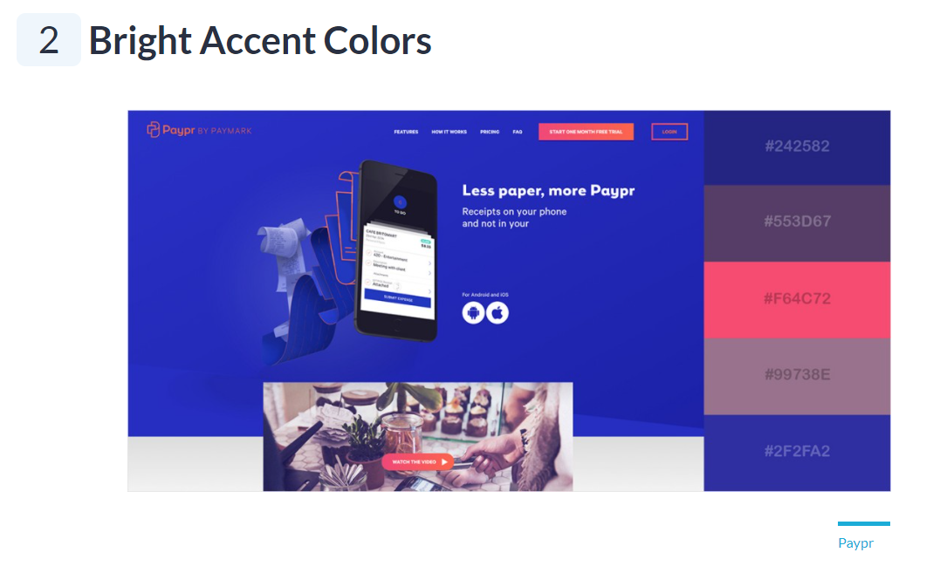  
Fig. 1 – Colour scheme that was used as a base.

However, due to the website’s structure, it was decided to make all sub-pages more related to each other by making the background gradient. Meaning, that a page has a background as a simple gradient from colour A to B and the following page has a background gradient from colour B to C, and in the same way until the end of the website. To transform taken colour scheme to border-colour-based gradient online-resource <https://coolors.co/gradient-palette/242582-f64c72?number=6> was used. The majority of the colours used as background are of the darker range, the colour of the text is set to white and white-mixed in contrast, to make it easy to read.

## Relations between sub-pages

Although the developed website has no externally linked sub-pages, it is important to provide some interconnection to allow users of potential customers faster navigation across pages. For that reason, every time page’s content has a mentioning of something that has an additional description on the website, the link is provided to the according section. Besides, almost all subpages of the website are linked in the navigation menu. The relationship and interconnection of all pages included in the website may be seen below in the design blueprint.

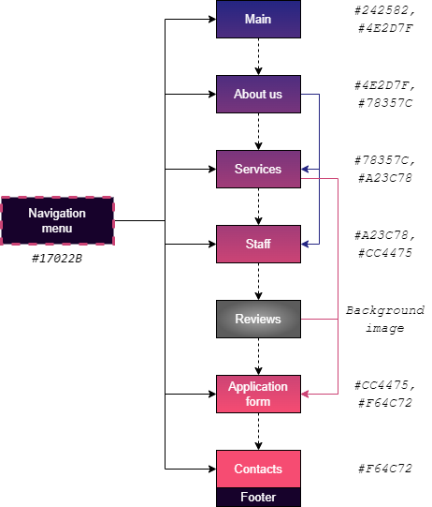  
Fig. 2 – Scheme (blue-print) of the developed website.

## Fonts

For displaying textual content, two main fonts were chosen: “Helvetica Neue” (default Bootstrap font) and “Jura” (Google font by Daniel Johnson). The first is used for headers and sub-headers, the second is used for all secondary text. To make “Helvetica Neue” appear more professional and modern, the headers use text transformation to uppercase and little increase in letter-spacing. The reason for choosing a different secondary text font is to not reveal the bootstrap “footprint” and also to put an emphasis on the company’s field of action – software. Although, view on font “character” is quite a subjective topic, chosen “Jura” font reminds somewhat of the “Consolas” or “Courier New” fonts, which are traditionally associated with computer text. In a way, the “Jura” font is a metaphor, reminding the reader of a computer-related (IT-related) topic.

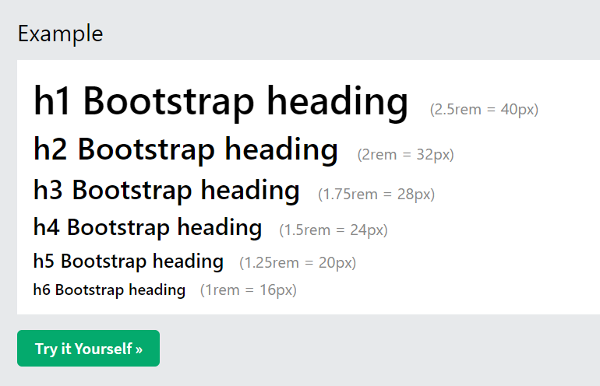  
Fig. 3 – Font “Helvetica Neue”

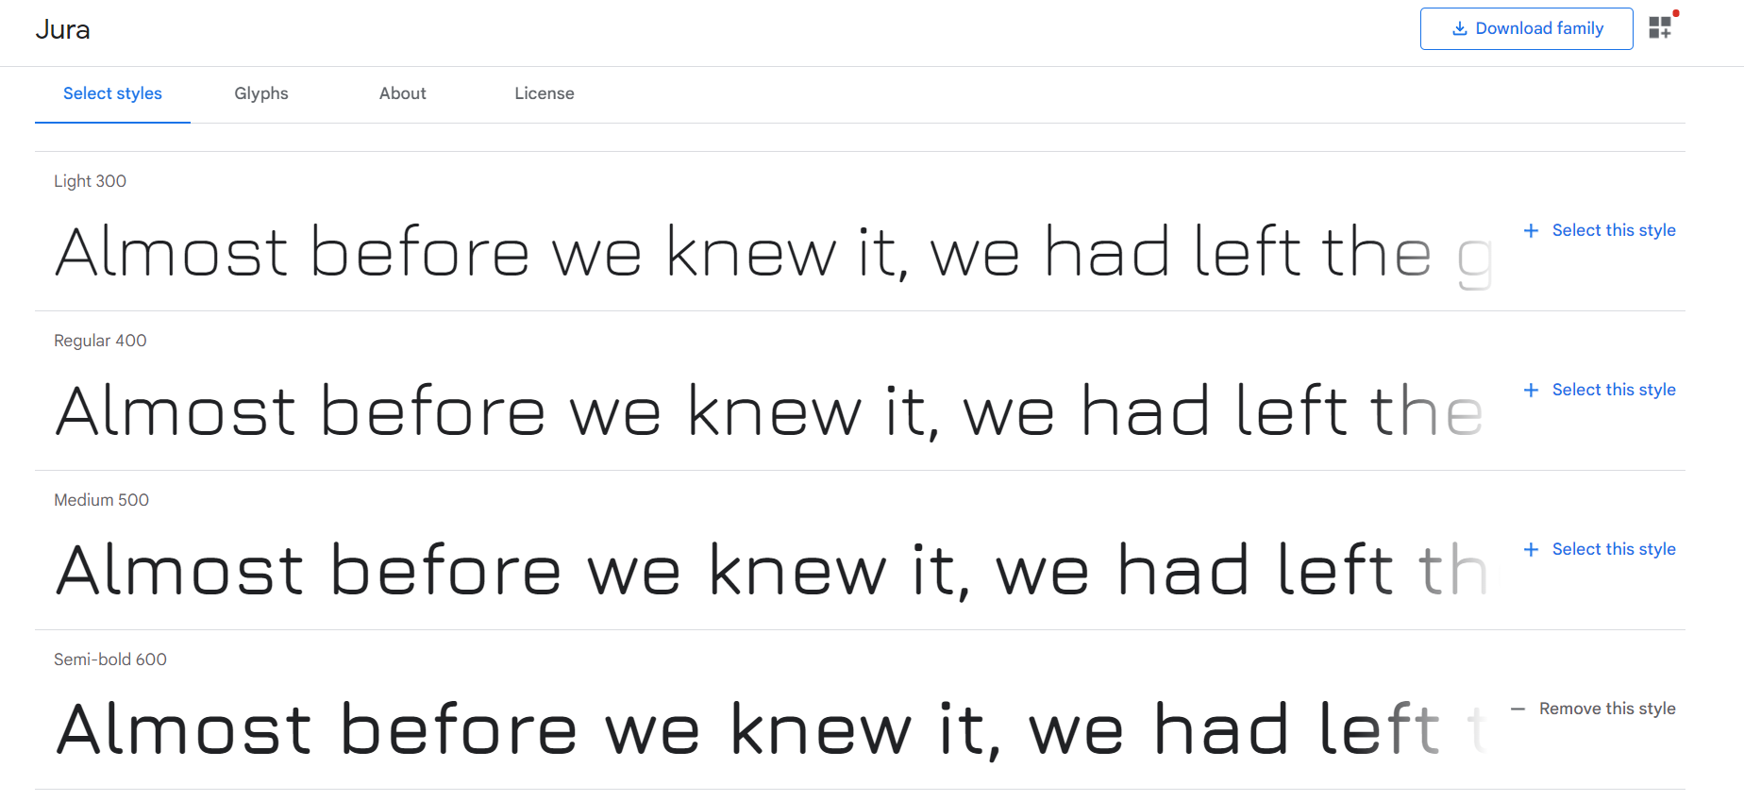  
Fig. 4 – Font “Jura”

## Media

The website is illustrated by images in the majority of subpages. The requirements for the illustrations were not specified in the provided task formulation, although to preserve aesthetical impression, the quality of chosen pictures should be of high resolution. In addition, to make the website appear professional, the pictures should also be high-quality photography/illustrations. For regular backgrounds and for the logo (which is a custom-created collage) the free professional online photo library <https://unsplash.com/> was used. This resource contains a lot of photography all available in high quality for free. In the section “Our staff” there are also photos of people. To not violate anybody’s private property or ethical laws, for pictures of people the neural network <https://thispersondoesnotexist.com/> was used. This resource allows to use (free of charge) neural network, created by Phil Wang, which acts based on the generative adversarial network (GAN) and generates hyper-realistic images of people that do not exist in reality.

## Uniform styling

To maintain the completeness of the website, a uniform design for each section and some elements were introduced.

* **Headers:** Each section has a header and a sub-header that are placed at the top of the section (top of the screen, when redirected via link) and aligned by the centre.
* **Text containers:** If the page is designed to have a lot of text, the contents are separated according to the theme and placed in a container with rounded borders, clearly stating the topic to which the text in the container is related.
* **Buttons:** All buttons have a transparent background and rounded rectangular borders. Each button has an animation that enables when user hovers on it.
* **Background pictures:** In case a picture is used as a background for a text container of the whole section, it should have opacity property. The degree of opacity is set for each case individually, depending on the colour of the section’s background or the type of content.
* **Icons:** All icons (taken from FontAwesome[3] or Bootstrap[4]) must have the same colour as all text (#FFFFFF – pure white) and have a margin of at least one blank space from the text they are included for.

# DEVELOPMENT

The next section is describing the technical aspects, practical implementation and all related nuances of each subpages’ development. Each subtopic will contain a screenshot of the final view of the developed website to demonstrate the structure and layout.

## Main page and navigation bar

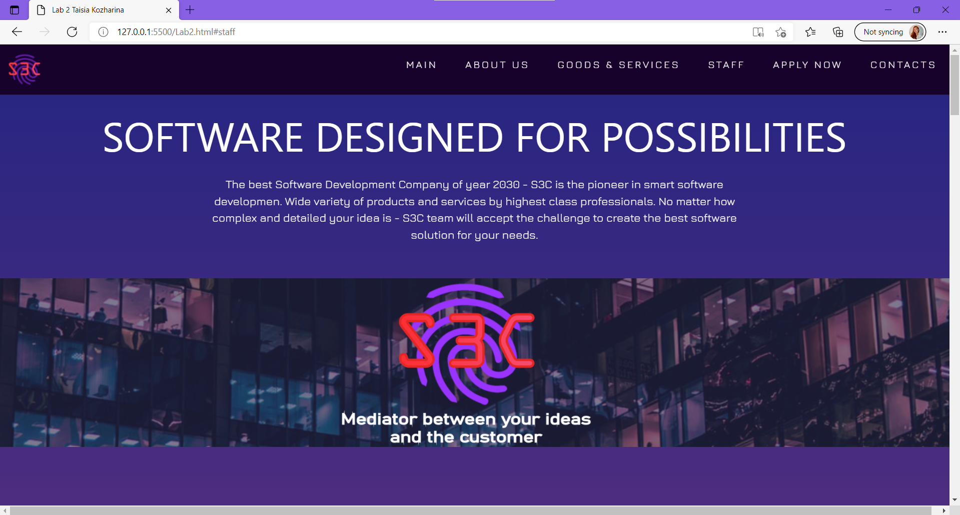  
Fig. 5 – screenshot of the main page of the developed website

As seen from the screenshot, the first page a user will see is the main page together with the navigation bar. The navigation bar is available to the user at any point of the website, but to allow more space for the main content, it is supplemented by scrolling animation: the navigation bar floats up and disappears as the user scrolls down on pages, but appears again with scrolling up. This effect is achieved by assigning a navigation bar (“nav class=’nav-bar’ in the source code”) a CSS property of position with value “fixed” and a z-index with value 10 (approximate value of “layout importance”, bringing navigation bar on top of any other content), complimented by JavaScript code.

The main page itself corresponds to section “main” in the source code and has a universal style of “header + content”. As the main page is the first page seen when the site is opened, it should be simple and informative. For the mentioned reason, the contents on this page reflect the brief description of the company and its custom-created banner. The layout of the main content sector of the page is organised in a grid form (provided by Bootstrap), as 2 rows: upper row for text and lower row as a pseudo-element, with no content, but assigned a background of the banner.

## About us

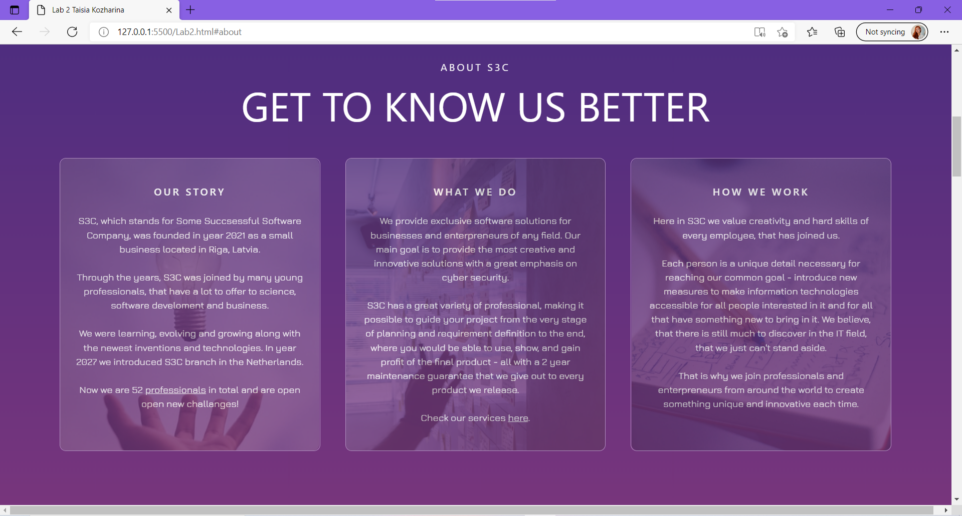  
Fig. 6 – screenshot of the “about us” page of the developed website

The “about us” page should contain deeper information about the company as data and history of creation and development of the company, structure, and executives of it (according to the provided requirements).

The “about us” page contains 3 sub-sections with information sorted by topic: “Our story” for the history of creation and development of the company, “What we do” for a brief introduction of provided services, “How we work” as a description of how the company is organised and mentioning of its values and priorities. To not duplicate some information described in more detail in the later sections, links to according sub-pages were included.

For the layout, again, is used grid system, consisting of a single row with 3 columns for 3 information blocks. According to the uniform styling, information boxes are rectangular with rounded borders. As the page contains a lot of text, for better readability there was included hover effect, which sizes up the content of the hovered-on box, making the text bigger and easier to read. To make information more entertaining, background illustrations for every information box were chosen such that they would be related to the topic. Background pictures are were made faded into the overall background, by assigning each section an “after” paragraph, which is not used in a traditional functional purpose – it is a tool for making the background fade in the main background. This trick is a necessity, as CSS does not yet have a background-opacity property, so it has to be done by introducing a so-called “pseudo-element”.

## Goods and services

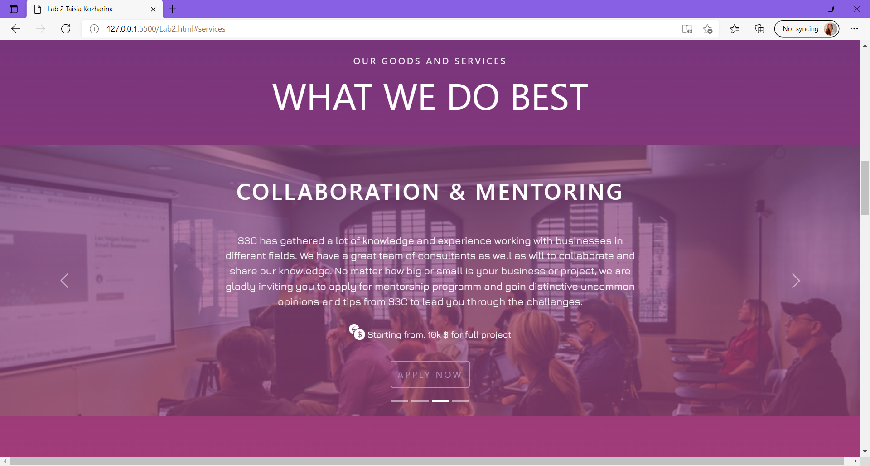  
Fig. 7 – screenshot of the “goods and services” page of the developed website

For reflecting provided services the slide-show structure was used, as fitting all information on one page statically would appear bulky and overloaded. For that Bootstrap feature – “Carousel”[5] was chosen. The carousel was supplemented with indicators (indication of what is the current slide) and controls (icons/buttons for next and previous slides). Each slide of 4 has an already known uniform style header + text, but with the addition of price reflection and button for application right away. The textual content is also divided into segments, that is maintained in all slides: the top is held by a header – the name of the service, in the middle, follows a brief description about what is offered in the frame of particular service, then at the bottom, there is an approximate price and the button for application form (transfer to sub-page “apply”). As both background pictures, giving an impression of the topic to the viewer, and the description of the service itself had to be put into each individual carousel slide – background overlay was used. The structure of each slide, therefore, looks as: “div.carousel-item” as the main container, having 2 “sub-divs”: “div.overlay-image” and “div.content”. In this section, again, image opacity equal to 0.35 is used to make the text of slides stand out more.

## Our employees

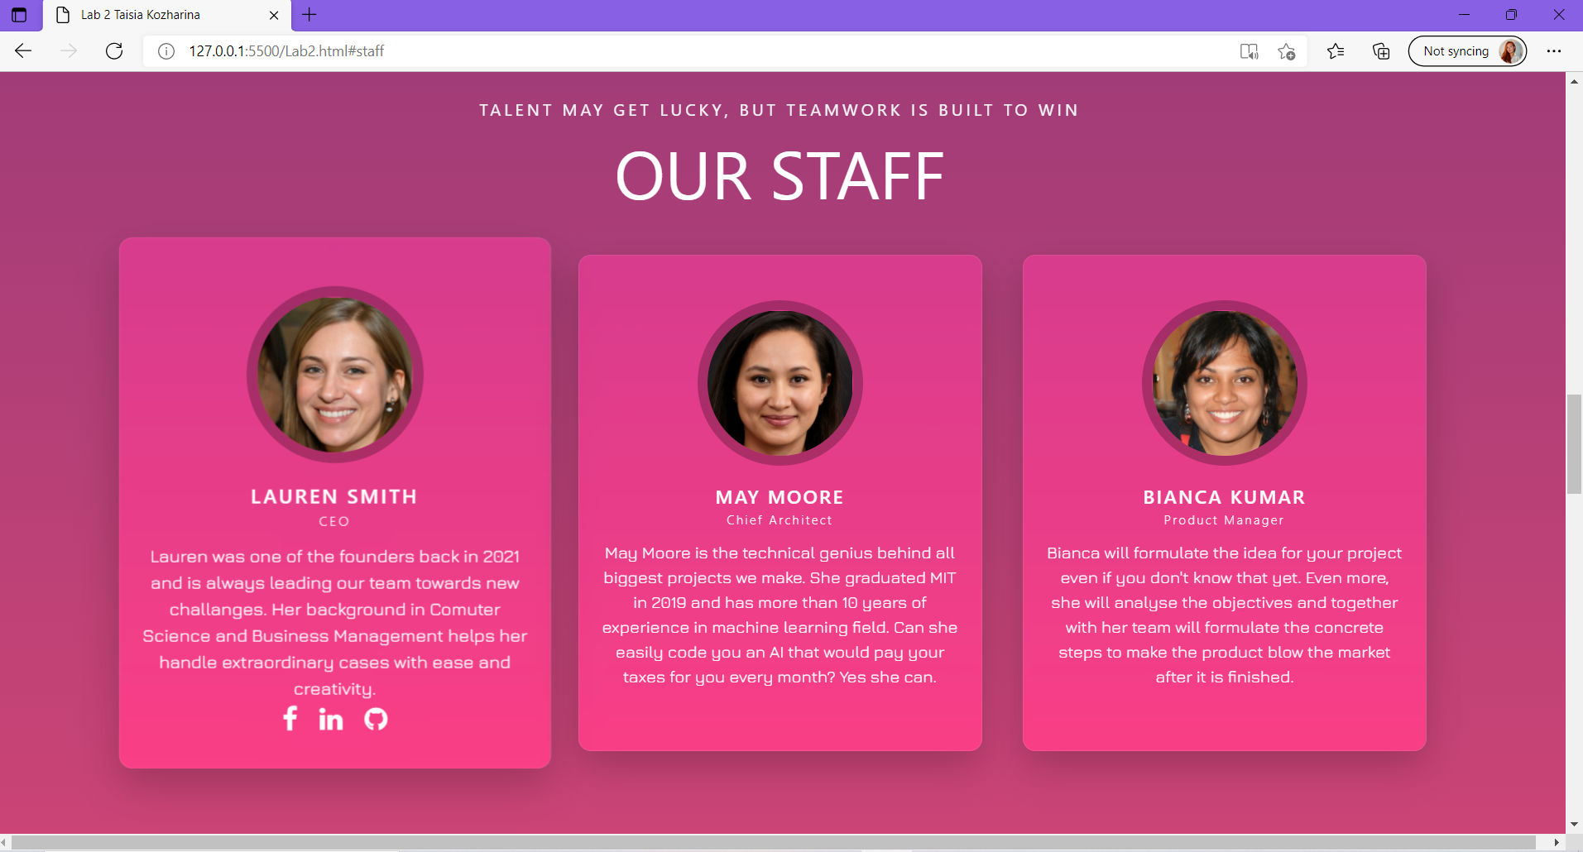  
Fig. 8 – screenshot of the “our staff” page of the developed website

In the current sub-page, the main company’s positions are presented. To not overload the page, only 3 persons were introduced. Similar, to other sections, content is organised into 3 boxes for each person. Each box uses the nested “div” structure to better organise the contents and is separated into 2 parts: content (consisting of the photo box, name box, and introduction box) and links to social media. According to the developed uniform design, each box is translated in size when hovered on.

## Customer reviews

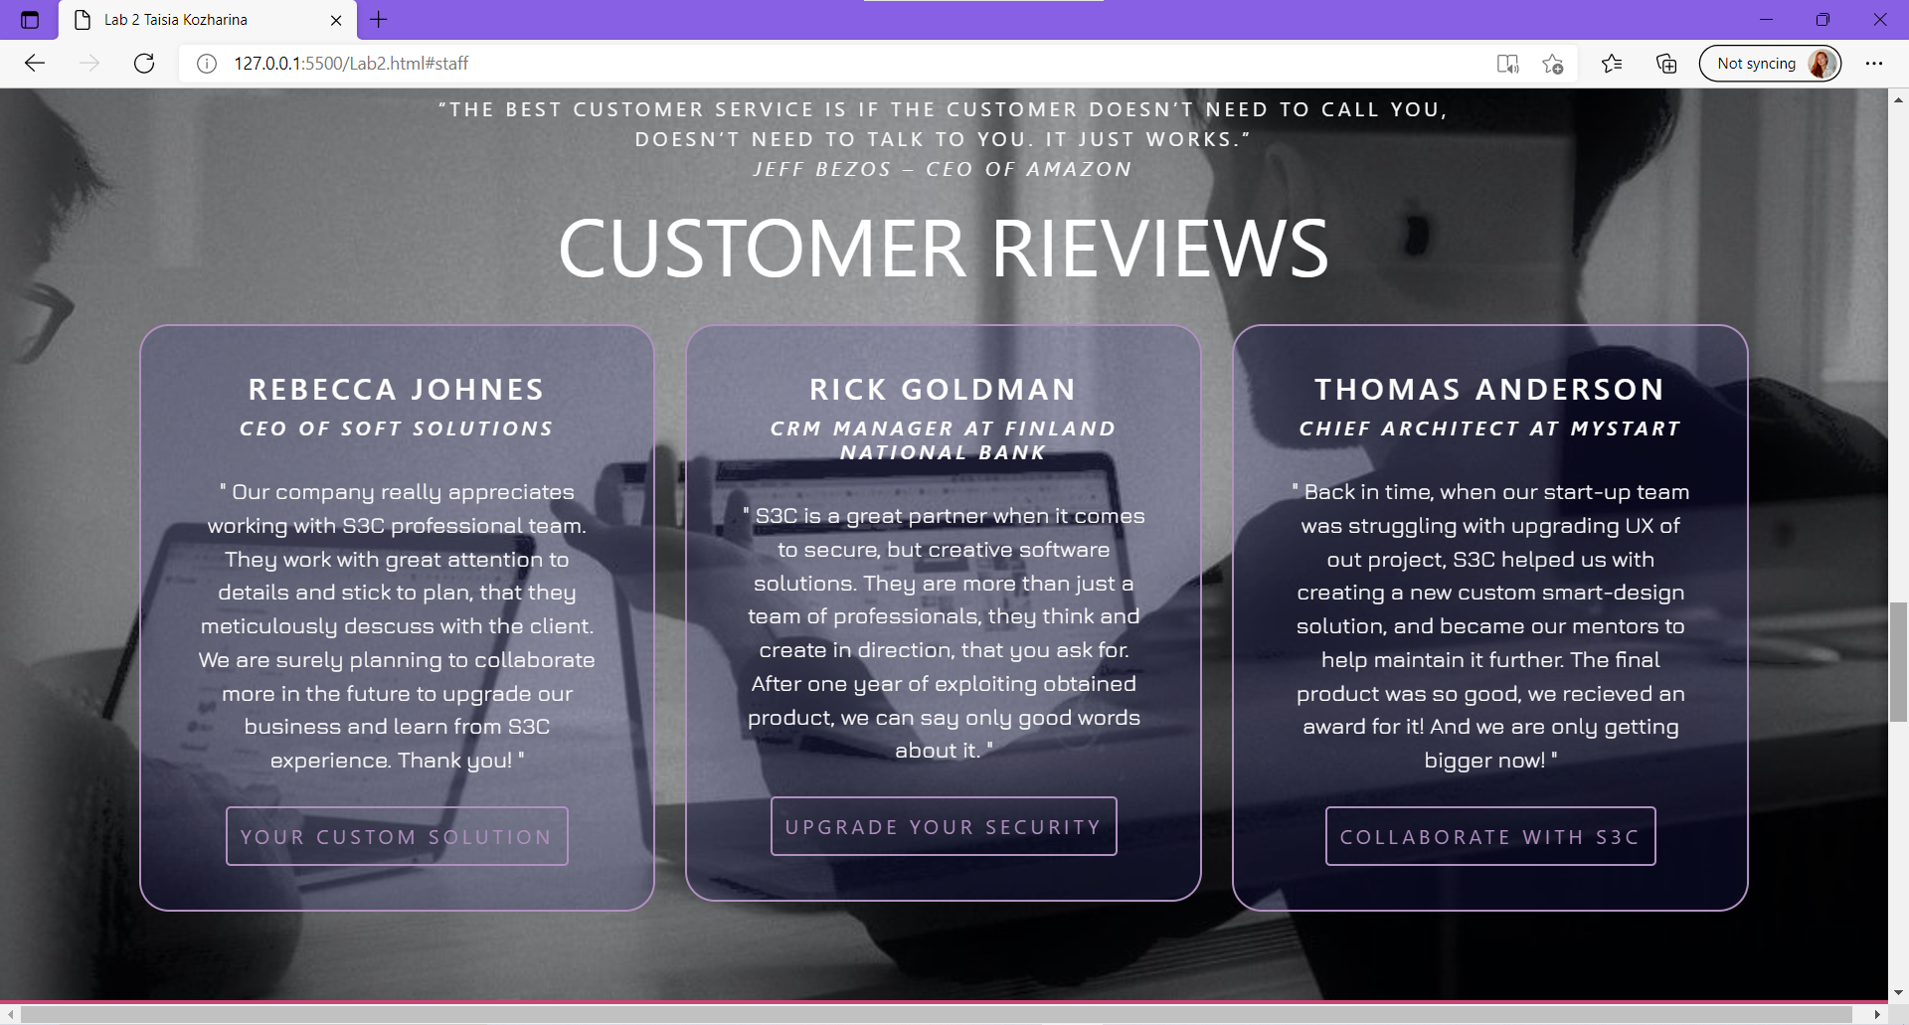  
Fig. 8 – screenshot of the “reviews” page of the developed website

Instead of putting customer reviews directly on the main page of the website, they were put in the place, where it would be logically correct according to the logic of the website’s dynamics – right before the application form to build additional trust before a client is ready to apply. Here, for the last time, the common grid structure is seen to organise contents in 3 boxes for 3 reviews. For the background, a picture was used. The effect of picture staying at one place nevertheless user scrolling up or down is achieved by including CSS attribute background-attachment with value “fixed” to the whole section.

## Submit an application

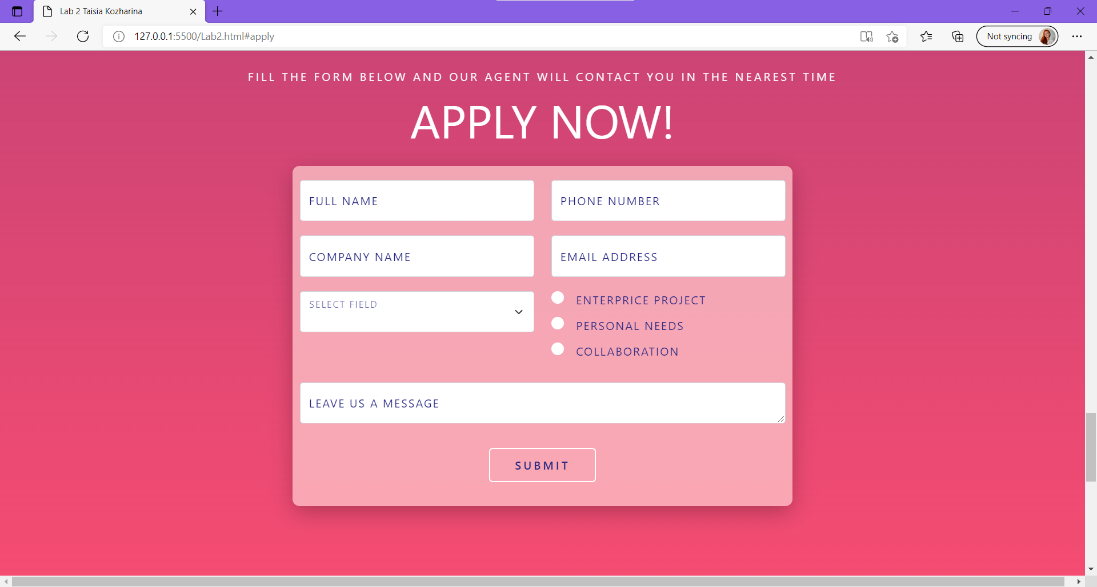  
Fig. 9 – screenshot of the “submit an application” page of the developed website

For the website’s application form a combination of Bootstrap components was chosen: grid and form containers[6] for creating a clear layout, and floating labels[7] for animation of form fields. The form uses JavaScript in regular expressions for validating user inputs. The regular expressions were customised to accept as many valid options as possible, at the same time restricting most common mistakes.

Although some sources state the redundancy of validating name and surname inputs in modern time (McKenzie, P., 2010)[8], it was included despite, as a great opportunity for practice. Looking at the approximate pattern of people’s names, it is common for Europeans to have a single name and a single surname, however, some people might have a double name or double surname. Taking the mentioned constraint into consideration the regex for a person’s name is “^([A-Z]{1}[a-z]{1,}[\s]*)*$”, meaning that input should contain any number of “words” corresponding to the pattern: one capital letter, blank space, any number of lowercase letters, words delimited by space. The regex for a telephone number is “^[+][0-9]{1,3}[ ][0-9]{4,10}$”, stating that the number should contain input in a form: +, country code (from 1 to 3 digits, as the longest country code in the world is only 3 digits, but the shortest is just one digit), blank space, actual phone number (again, the longest telephone numbers in the world are of 10 digits, but shortest of 4 digits). The regex is adopted inside the “input” tags attribute “pattern”, which excepts JavaScript-adapted regular expressions, with the addition of attribute “required”, which causes the empty string to also toggle error state. Other fields use default validation, as, for example, the field with e-mail. This is achieved by assigning a type to an input. The input field with type = “email” with ask from user to input the whole e-mail address, with right part, “@” sign and left part with “.” symbol.

As the website is simply a maquette developed in the frame of laboratory form, the information from the form is not saved or sent anywhere. Although, it is possible if the form tag would contain information about the server or the file to send information to. Due to that, by pressing the “submit” button, and having no mistakes in the inputs, a user is then redirected to the same application section, but the form would be emptied.

## Contact us

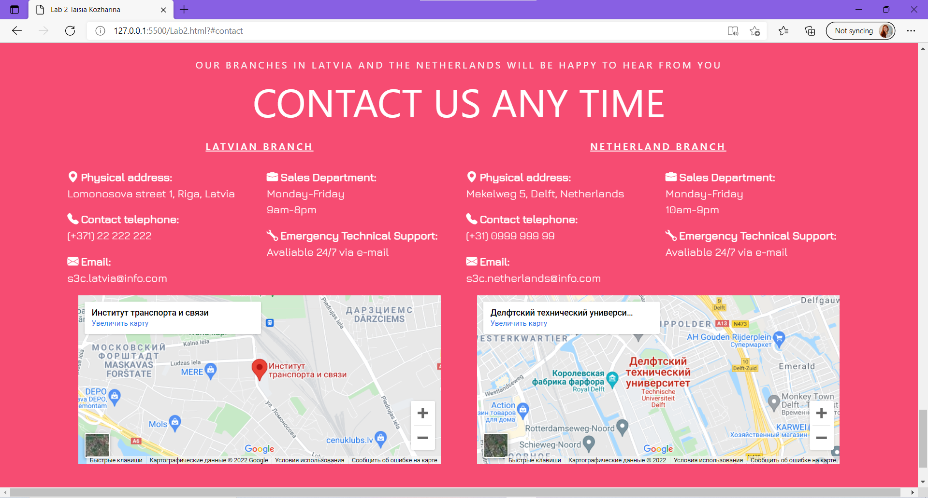Fig. 10 – screenshot of the “contact us” page of the developed website

The contact information of the company is displayed without major decorations, to not drag attention from the main sub-pages and for the user to find all needed information in an easy table format. For clarity, Bootstrap icons are used to delimit rows of information. The section uses a nested grid system: all section (without header) is one row, having two columns for Latvian and Netherland branches. Each column is also divided into two rows for textual contact information and map display. And lastly, the upper row of each branch is divided into two columns to gain better control of the layout, both columns organised as unordered lists. For the display of the interactive map, Google Maps were used. The physical addresses of branches were chosen to be Transport and Telecommunication Institute (Latvia) and the Delft University of Technology (the Netherlands), so the mark on the map, the format of the phone number, and the addresses corresponds to above mentioned.

# TESTING

The following section will reflect the procedure of the testing. All test cases, along with expected behaviour and results will be presented. If any mistakes would occur during testing, there also will be included the analysis or the error, and its’ correction procedure.

Although any imperfections regarding domains of technical performance, design, and grammatical correctness may be considered errors, description of the real testing procedure and its results would become ambiguous and very long. Therefore, only major functionality and overall design features will be examined in this section.

All testing cases will be performed in two browsers: Google Chrome and Microsoft Edge to catch possible browser-interpretation mistakes.

## Test case #1

Expected behaviour: website loads, within a relatively small timeframe. The website opens on the main page, with a pinned navigation bar. The main page takes the whole length and width of the screen.

Actual behaviour: as expected. No errors occurred in the process of testing.

## Test case #2

Expected behaviour: The navigation bar has all the needed links. Each link redirects the user to the correct subsection. The navigation bar hides when scrolling down and appears again when scrolling up at any point of the page.

Actual behaviour: as expected. No errors occurred in the process of testing.

## Test case #3

Expected behaviour: embedded links and buttons work properly. They are highlighted and well seen. Links and buttons redirect the user to the correct sub-page.

Actual output: Two bugs (one bug with 2 links) have occurred during the testing procedure. In the section “About us” there are several links that are embedded in the text. Both links do not work, as the text seems to be overlayed by some other elements. This hypothesis is supported by the impossibility to highlight (select) text with a mouse.

Fixing: The first idea to fix a problem with layering is to introduce layer indexing, in HTML this is achieved through adding a CSS property “z-index” for needed elements. The element that is blocking the text may be seen in the inspect element of the browser.

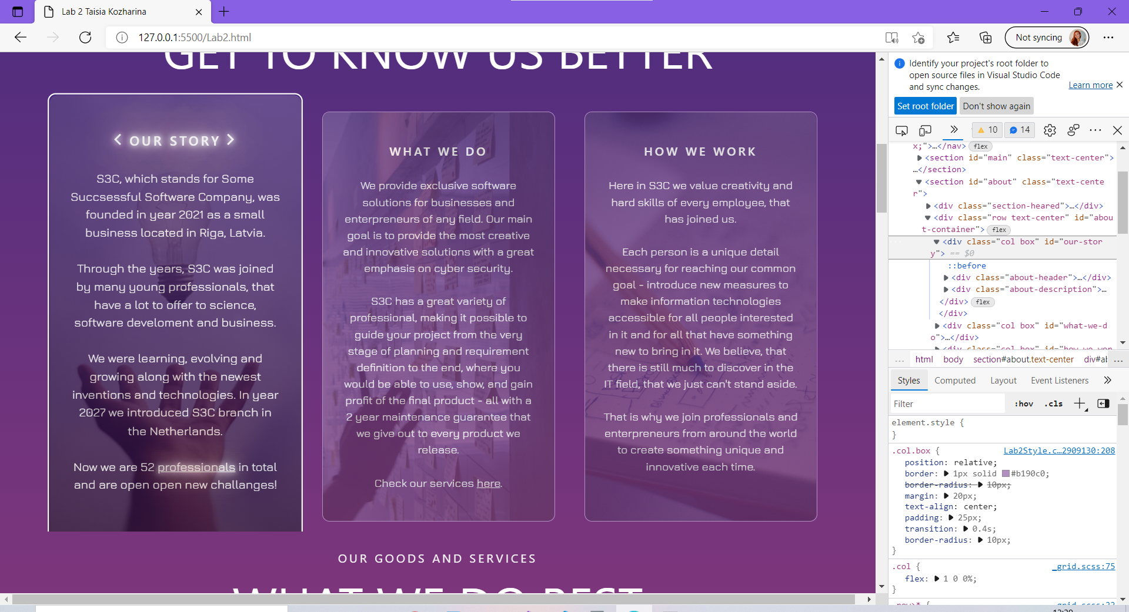

Fig. 11 – inspect mode of the section “About us”

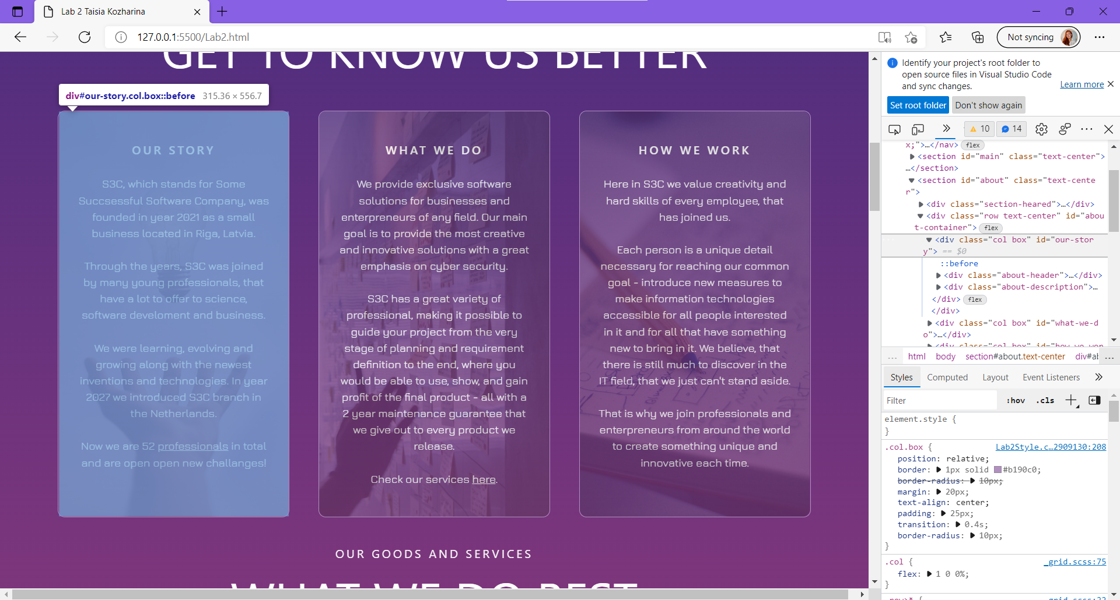

Fig. 12 – inspect mode shows element “before” related to element “div class = col box id = our story” that is blocking the text.

By placing property “z-index: -1” for element “.col.box::before” int the CSS file, the view of the page changes. The text is now highlightable and the link is available to click and redirect user, but the background pictures vanish in a non-hover mode, which is not the desired style. This effect is seen in the figure below.

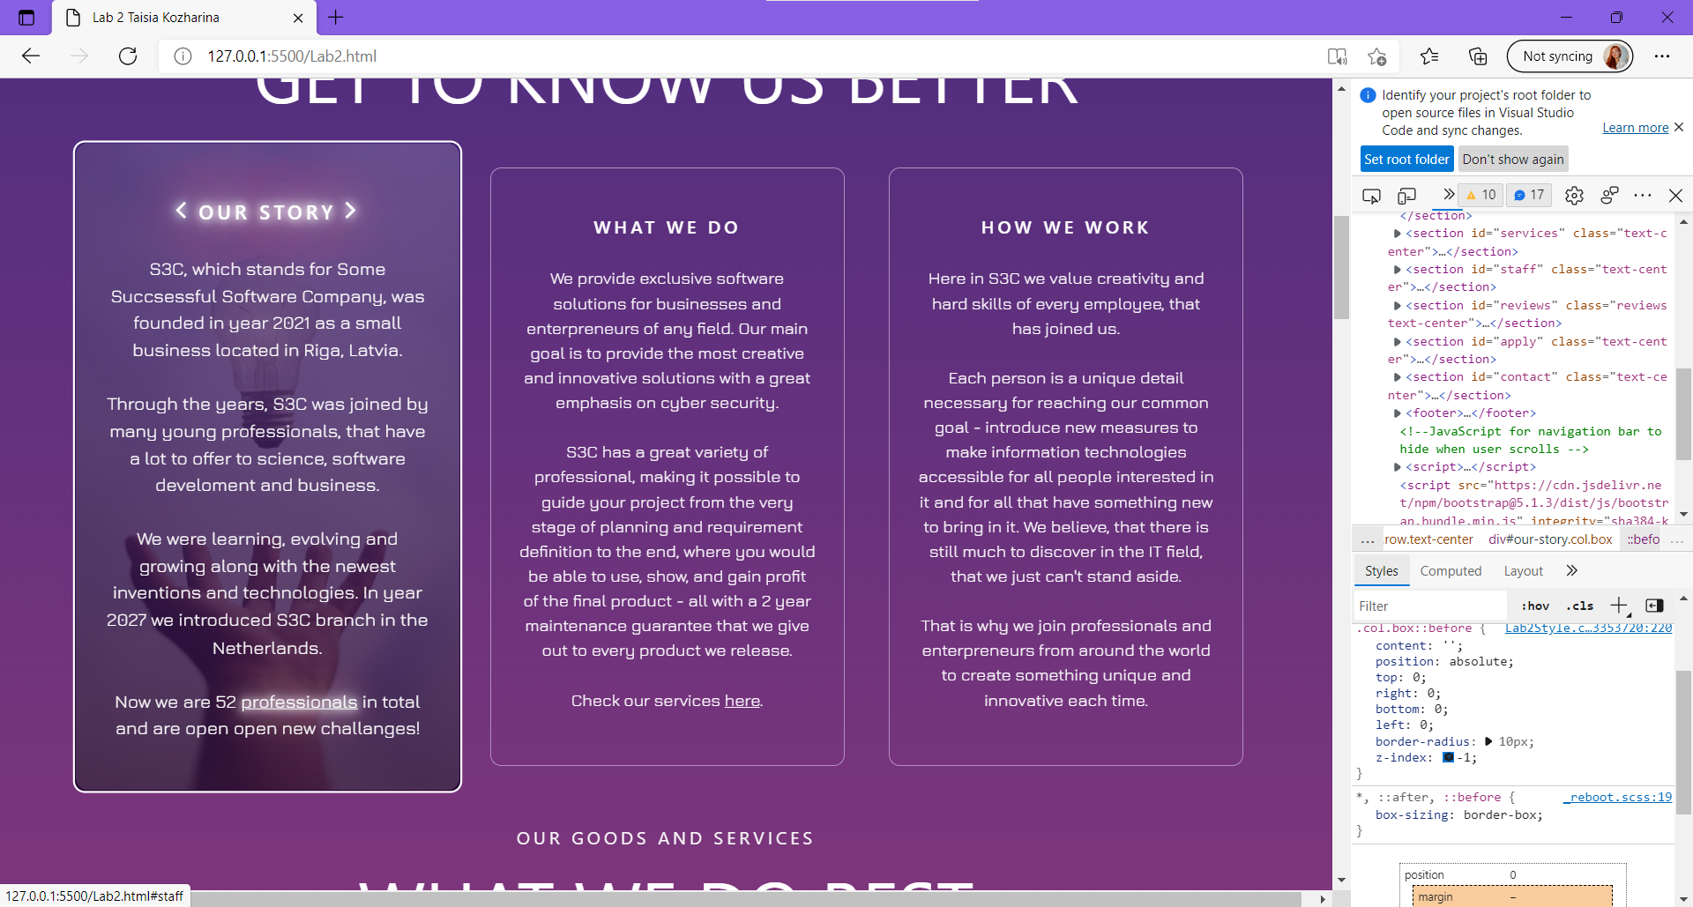

Fig. 13 – when hovering at the first box, background pictures appear, and the link is   
available, but no background pictures are seen on the non-hovered boxes.

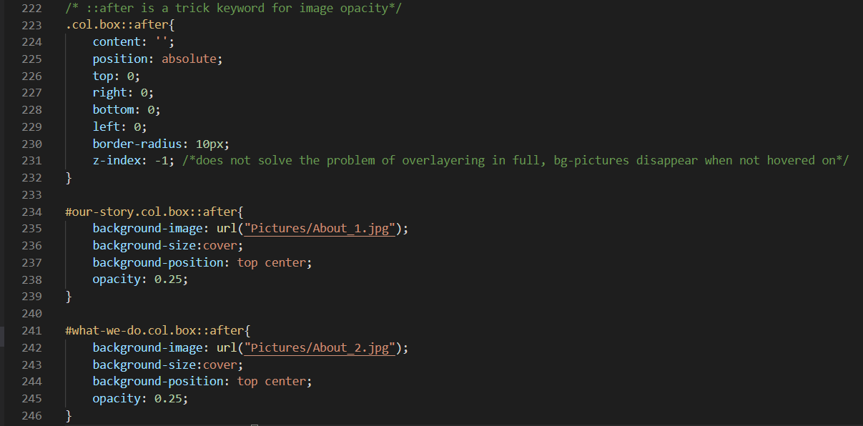

Fig. 14 – Code corrections in CSS in line 231

After performing some research, it was found out that z-indexing does not always work as simple as it sounds and there are a number of reasons for it (Chan, J., 2019)[9]:

1: Elements in the same stacking context will display in order of appearance, with latter elements on top of former elements.

2: The element doesn’t have its position set.

3: Setting some CSS properties like opacity or transform will put the element in a new stacking context.

4: The element is in a lower stacking context due to its parent’s z-index level.

The problem with text blocking was laying in the positions and the z-indexes of the elements. As previously denied fixing approach proved, the z-index can help bring elements on top on underneath other elements, but it only works when the position is set to anything other than static. When tried to apply z-index to elements of the static position, no effect was seen, but when added property “position: relative” and then the z-index (equal to 1, but the number does not matter as long as it is more than zero, because other elements in the boxes do not have z-index).

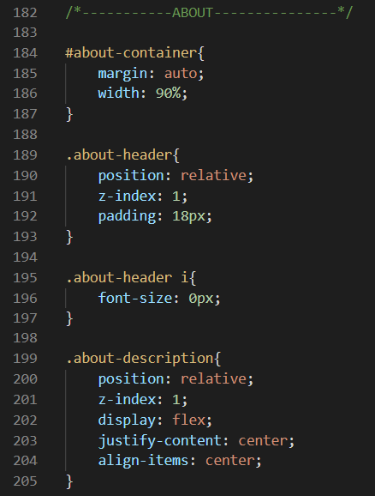  
Fig. 15 – Code corrections in lines 190 and 200 (positions) and 191 and 201 (z-indexes)

After performing corrections, described and shown above, both links work perfectly and the text is highlightable (meaning, that it is the top element in the container).

## Test case #4

Expected behaviour: All text, presented on the web page is readable, the size and colour of it are appropriate. In case of explicitly planned hover-on effects, the text becomes bigger and is still inside the container, the layout is not distorted.

Actual behaviour: The majority of the text is well-readable and has a proper layout, but one imperfection was found in the section “Our Staff”. The bug is appearing when hovering on one of the boxes. The whole box is transformed to be 1.07 times bigger than the initial size for better readability and the text becomes blurred. The effect may be seen in the figure below.

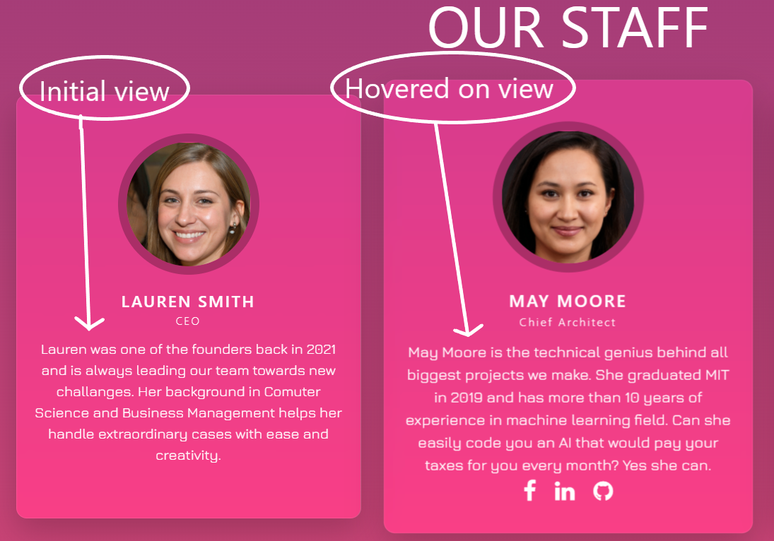  
Fig. 16 – Difference between hovered and non-hovered text

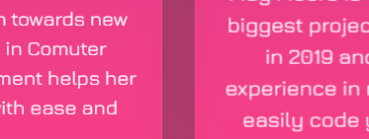  
Fig. 17 – A closer look at differences. The left box is non-hovered and the right box is hovered on.   
Blurring on the right side is noticeable right away.

Fixing: The problem appeared to be quite popular among the web-developed community, as seen from the discussion on [Stack Overflow](https://stackoverflow.com/questions/14677490/blurry-text-after-using-css-transform-scale-in-chrome). The one solution, proposed by [Gabriel G](https://stackoverflow.com/users/8384377/gabriel-g). in the discussion was to introduce the “transform-origin” property for the element that is causing distortion. This solved the problem with blurring, but introduced a new problem with the layout, as it takes the upper left corner of the container as origin and demands to leave it at its original position regarding the parent container. Whereas, the “transform: scale (1.07)” (initially used for toggling the size of the box alone), takes centre of the container as the origin. The effect of adding the “transform-origin” property is presented in the figure below.

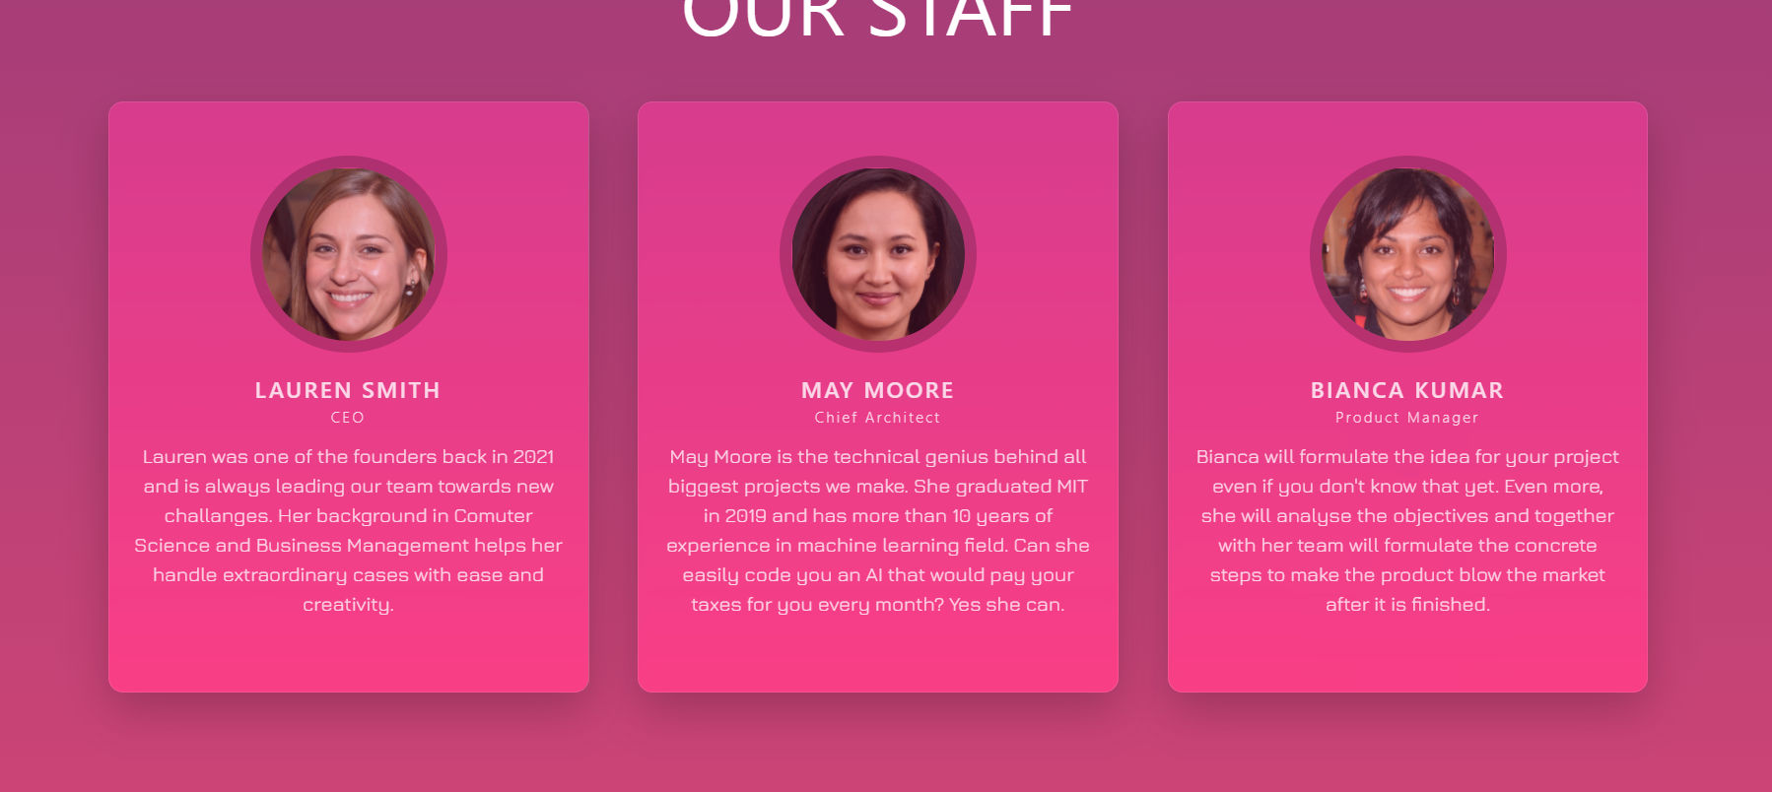  
Fig. 18 – Initial view of the page with added CSS corrections

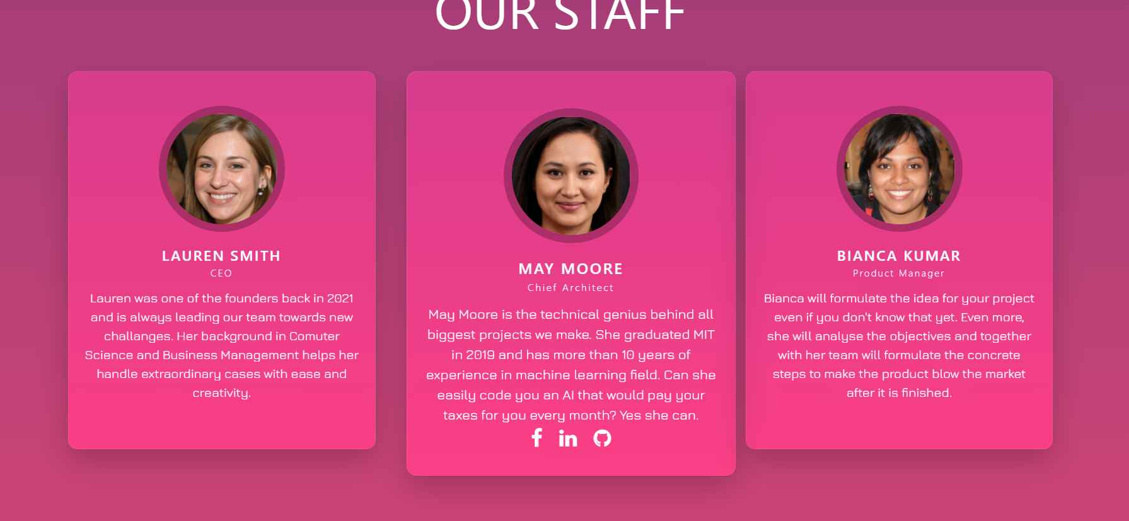Fig. 19 – View of the page, when hovered on the middle box with added CSS corrections

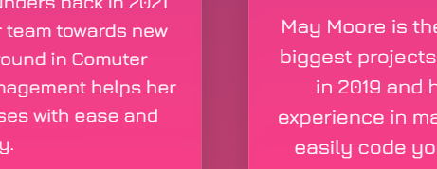  
Fig. 20 – A closer look at text differences: the left part is a non-hovered box,   
the right part is the hovered-on box. As seen, no blurring is present.

No manipulations with values of “transform-origin” other than values = {0% 0} worked to solve the blurring problem. On top of that, no other approaches from the mentioned stackoverflow.com helped either. Finally, the dilemma of sacrificing the layout over readability or vice versa was resolved in the favour of layout. The blurring of the text may be an issue of browsers interpretation of the HTML and CSS codes (however, the bug was present in both browsers under test), or related to the resolution of the screen, but the layout problem, occurring when blurring is fixed, will be present in all cases and look quite unprofessional.

## Test case #5

Expected behaviour: The form does not accept empty input in required fields (Full name, Phone number, E-mail). Form does not accept inputs in the incorrect format in the field with name and phone number. Animation in the form works properly: all labels except for “Select field” are floating when active, radio buttons are highlighted in light blue when hovered on and coloured in dark blue when selected, the message box is resizable, submission button is highlighted when hovered on.

Testing inputs:

Name: *empty input* (should not be accepted)

Name: john eric smith (should not be accepted)

Name: John eric smith (should not be accepted)

Name: J E S (should not be accepted)

Name: J. Smith (should not be accepted)

Name: John-Eric Smith (should not be accepted)

Name: John Eric Smith (should be accepted)

Phone number: 912345678 (should not be accepted)

Phone number: 91 2345678 (should not be accepted)

Phone number: +9 123 (should not be accepted)

Phone number: +9999 12345678 (should not be accepted)

Phone number: +99 123456789123 (should not be accepted)

Phone number: +912345678 (should not be accepted)

Phone number: (+91) 2345678 (should not be accepted)

Phone number: +91 23 45 678 (should not be accepted)

Phone number: (+91) 23 45 678 (should not be accepted)

Phone number: +91 2345678 (should be accepted)

E-mail: *empty input* (should not be accepted)

E-mail: test (should not be accepted)

E-mail: test@ (should not be accepted)

E-mail: t@st@test.com (should not be accepted)

E-mail: test@test.com (should be accepted)

Actual behaviour: All testing input passed, form behaved as expected with no bugs.

## Results

Collection of formatted results of the testing procedures reflecting each testing case may be seen in the table below.

Table 1 – Results of testing

|  |  |  |  |  |  |  |
| --- | --- | --- | --- | --- | --- | --- |
| **Test case** | **Tested features** | **Tested area** | **Success of testing** | **Occurred bugs** | **Bug status** | **Result** |
| **1** | Opening of the website. Reflection of the main page and navigation bar. | Main page | Passed | - | - | Passed |
| **2** | Functionality of navigation bar. Proper work of all links, scrolling effect. | Navigation bar | Passed | - | - | Passed |
| **3** | Proper work of any embedded links and buttons. Check of redirection to correct page | About us, Services, Staff, Reviews, Application form | Partially passed | Section “About us” contains 2 links in the text, which does not work. | The bug was fixed by adding position and z-indexes for text, description is presented in the according sub-section. | Passed |
| **4** | Readability of all text, layout, and its position on the page. | All website | Partially passed | Sections “Our staff” has blurred text when hovered at. | The solution was found but caused other problems, so the bug deliberately was left unfixed. | Partially passed |
| **5** | Input validation of the form | Application form | Passed | - | - | Passed |

# CONCLUSIONS

In the frame of laboratory work #2, a static website was developed according to an individually assigned topic. The development was completed and all related issues and procedures were described in the previous sections.

Although the work is finished and all necessary requirements regarding format and contents have been satisfied, the website has its limitations. The most obvious limitation is that the scalability of the developed site is very constrained. The only possible way to observe and enjoy the website is to open it in a maximised browser window. As this project turned out quite complex and nuanced in the technical sense, it would require more and more time to make it size-adjustable. Similarly, the scaling of the contents (usually implemented by key combination “Ctrl +” in the browser window) is supported poorly: the layout would most probably display distorted and overlayed.

As seen from the testing section, there were some technical errors revealed, that were not corrected, due to a lack of appropriate information and/or personal knowledge. Because of that, some section(s) may appear more difficult to read or concentrate view on.

Nevertheless, the website fulfilled most of the initially stated technical requirements and may now be ready to use. Looking in the future, the project definitely has room for improvement. The main domain of further development is its scalability and responsive layout.

On a final note, this laboratory work was a true challenge for a beginner web developer, as it required some in-depth knowledge not only in HTML and CSS languages, but also in web design, technical features of browsers, and other web-related topics, and was quite time-consuming and resource-consuming. Yet, the laboratory work is completed and the process of working on it has taught me a lot of technical skills as well as proper website planning and production techniques. I am very much looking forward to continuing to work on the presented project and improving it to gain more knowledge and experience in web development.

# REFERENCES

* <https://stackoverflow.com/questions/45536537/centering-in-css-grid>
* <https://getbootstrap.com/docs/5.1/layout/grid/>
* <https://getbootstrap.com/docs/5.1/forms/validation/>
* <https://getbootstrap.com/docs/5.1/forms/overview/>
* <https://getbootstrap.com/docs/5.1/components/buttons/>
* <https://getbootstrap.com/docs/5.1/components/carousel/>
* <https://www.w3schools.com/tags/att_input_type_tel.asp>
* <https://countrycode.org/>
* <https://stackoverflow.com/questions/53115746/how-can-i-overwrite-the-style-of-primary-button-in-bootstrap>
* <https://stackoverflow.com/questions/30956383/dividing-bootstrap-grid-into-sub-grid/30957443>
* <https://stackoverflow.com/questions/8605516/default-select-option-as-blank>
* <https://stackoverflow.com/questions/33761594/border-around-bootstrap-container>
* <https://www.youtube.com/watch?v=s6rF1Josk9M>
* <https://www.youtube.com/watch?v=serCnYVPZD0>
* <https://www.youtube.com/watch?v=ku_97a6Bgkg>
* <https://stackoverflow.com/questions/49156966/change-image-size-on-hover/49157246>
* <https://stackoverflow.com/questions/3029422/how-do-i-auto-resize-an-image-to-fit-a-div-container>
* <https://stackoverflow.com/questions/13896331/displaying-two-or-more-unordered-lists-next-to-eachother>
* <https://coderedirect.com/questions/586189/bold-fonts-in-google-chrome-are-blurry-font-face>
* <https://getbootstrap.com/docs/5.0/forms/floating-labels/>

# ANNEX

## Source code: HTML (Lab2.html)

<!DOCTYPE html>

<html lang="en">

<head>

    <meta charset = "UTF-8">

    <meta name = "author" content="Taisia Kozharina">

    <meta name = "description" content="This is a simple static website developed in the frame of Laboratory work

    #2 in the course Web Application Development.">

    <meta name="viewport" content="width=device-width, initial-scale=1">

    <title>Lab 2 Taisia Kozharina</title>

    <link rel = "stylesheet" href="Lab2Style.css">

    <!-- Link to bootstrap -->

    <link href="https://cdn.jsdelivr.net/npm/bootstrap@5.1.3/dist/css/bootstrap.min.css" rel="stylesheet" integrity="sha384-1BmE4kWBq78iYhFldvKuhfTAU6auU8tT94WrHftjDbrCEXSU1oBoqyl2QvZ6jIW3" crossorigin="anonymous">

    <!-- ink to fontawesome for icons -->

    <link rel="stylesheet" href="https://cdnjs.cloudflare.com/ajax/libs/font-awesome/4.7.0/css/font-awesome.min.css">

    <!-- ink to bootstrap for icons -->

    <link rel="stylesheet" href="https://cdn.jsdelivr.net/npm/bootstrap-icons@1.7.2/font/bootstrap-icons.css">

</head>

<body>

    <nav class="nav-bar">

        <a href="#main"><img src="Pictures/Logo.png" alt="Logo" class="Logo"></a>

        <!-- Navigation/menu that will be fixed on the top of the screen -->

        <ul id="menu">

            <li><a href="#main"><p class="header-title">Main</p></a></li>

            <li><a href="#about"><p class="header-title">About us</p></a></li>

            <li><a href="#services"><p class="header-title">Goods & Services</p></a></li>

            <li><a href="#staff"><p class="header-title">Staff</p></a></li>

            <li><a href="#apply"><p class="header-title">Apply now</p></a></li>

            <li><a href="#contact"><p class="header-title">Contacts</p></a></li>

        </ul>

    </nav>

    <section id="main" class="text-center">

        <br/><br/><br/>

            <div class="section-heared">

                <div class="header-subtitle">Software designed for possibilities</div>

            </div>

            <div class="row" id="upper-main">

                    <p>The best Software Development Company of year 2030 - S3C is the pioneer in

                        smart software developmen. Wide variety of products and services by highest class professionals.

                        No matter how complex and detailed your idea is - S3C team will accept

                        the challenge to create the best software solution for your needs.

                    </p>

            </div>

            <div class="row" id="lower-main"><!--Div for main banner--></div>

    </section>

    <section id="about" class="text-center">

        <div class="section-heared">

            <div class="header-title">About s3c</div>

            <div class="header-subtitle">Get to know us better</div>

        </div>

        <div class="row text-center" id="about-container">

            <div class="col box" id="our-story">

                <!-- <img src="Pictures/About_1.jpg" alt="lightbulb" class = "about-overlay"> does not work as background-->

                <div class="about-header">

                    <h6><i class="fa fa-angle-left"></i>  Our story  <i class="fa fa-angle-right"></i></h6>

                </div>

                <div class="about-description">

                    <p>S3C, which stands for Some Succsessful Software Company, was

                    founded in year 2021 as a small business located in Riga, Latvia.

                    <br/><br/>Through the years,

                    S3C was joined by many young professionals, that have a lot to offer to science, software

                    develoment and business.

                    <br/><br/>We were learning, evolving and growing along with the newest inventions and technologies.

                    In year 2027 we introduced S3C branch in the Netherlands.

                    <br/><br/>Now we are 52 <a href="#staff">professionals</a> in total

                    and are open open new challanges!

                    </p>

                </div>

            </div>

            <div class="col box" id="what-we-do">

                <!-- <img src="Pictures/About_2.jpg" alt="planning board, meeting" class = "about-overlay"> -->

                <div class="about-header">

                    <h6><i class="fa fa-angle-left"></i>  what we do  <i class="fa fa-angle-right"></i></h6>

                </div>

                <div class="about-description">

                    <p>We provide exclusive software solutions for businesses and

                    enterpreneurs of any field. Our main goal is to provide the most creative and innovative solutions

                    with a great emphasis on cyber security.

                    <br/><br/>S3C has a great variety of professional, making it possible

                    to guide your project from the very stage of planning and requirement definition to the end, where you

                    would be able to use, show, and gain profit of the final product - all with a 2 year maintenance guarantee

                    that we give out to every product we release.

                    <br/><br/>Check our services <a href="#services" >here</a>.

                    </p>

                </div>

            </div>

            <div class="col box" id="how-we-work" >

                <!-- <img src="Pictures/About_3.jpg" alt="notes and pen" class = "about-overlay"> -->

                <div class="about-header">

                    <h6><i class="fa fa-angle-left"></i>  How we work  <i class="fa fa-angle-right"></i></h6>

                </div>

                <div class="about-description">

                    <p>Here in S3C we value creativity and hard skills of every employee, that has joined us.

                        <br/><br/>Each person is a unique detail necessary for reaching our common goal - introduce new measures

                        to make information technologies accessible for all people interested

                        in it and for all that have something new to bring in it. We believe, that there is still much to discover

                        in the IT field, that we just can't stand aside.

                        <br/><br/>That is why we join professionals and

                        enterpreneurs from around the world to create something unique and innovative each time.

                    </p>

                </div>

            </div>

        </div>

    </section>

    <section id="services" class="text-center">

        <div class="section-heared">

            <div class="header-title">our goods and services</div>

            <div class="header-subtitle">what we do best</div>

        </div>

        <br/>

        <div id="carouselServices" class="carousel slide" data-bs-ride="carousel">

            <div class="carousel-indicators">

                <button type="button" data-bs-target="#carouselServices" data-bs-slide-to="0" class="active" aria-current="true" aria-label="Slide 1"></button>

                <button type="button" data-bs-target="#carouselServices" data-bs-slide-to="1" aria-label="Slide 2"></button>

                <button type="button" data-bs-target="#carouselServices" data-bs-slide-to="2" aria-label="Slide 3"></button>

                <button type="button" data-bs-target="#carouselServices" data-bs-slide-to="3" aria-label="Slide 4"></button>

            </div>

            <div class="carousel-inner">

                <div class="carousel-item" >

                    <div class="overlay-image" style="background-image: url(Pictures/Secrive-Data.jpg)"></div>

                    <div class="container crsl">

                        <h1>Data-driven solutions</h1>

                        <p>Data is the new money. Let us create a unique analytical plan for your project and

                            navigate it according to "data-first" principle. Techniques such as data-mining, analytics,

                            and cloud-computing will be used to make the most of your data.

                            As a result you will be able to provide a better and more thoughtful service to your clients.

                        </p>

                        <div class="price">

                            <p><i class="bi bi-currency-exchange"></i> Starting from: 25k $ for full project</p>

                        </div>

                        <a href="#apply" class="btn">Apply now</a>

                    </div>

                </div>

                <div class="carousel-item">

                    <div class="overlay-image" style="background-image: url(Pictures/Service-AI.jpg)"></div>

                    <div class="container crsl">

                        <h1>Artificial intelligence</h1>

                        <p>Level-up your business processes, decrease costs of labour, improve productivity, all with

                            implementing AI. New systems, that learn and adapt to make your company bigger and smarter.

                            S3C will show you exactly where and how to implement it, and help you and AI get to know each other

                            to work efficiently together to achieve more.

                        </p>

                        <div class="price">

                            <p><i class="bi bi-currency-exchange"></i> Starting from: 60k $ for full project </p>

                        </div>

                        <a href="#apply" class="btn">Apply now</a>

                    </div>

                </div>

                <div class="carousel-item">

                    <div class="overlay-image" style="background-image: url(Pictures/Service-Mentoring.jpg)"></div>

                    <div class="container crsl">

                        <h1>Collaboration & Mentoring</h1>

                        <p>S3C has gathered a lot of knowledge and experience working with businesses in different fields.

                            We have a great team of consultants as well as will to collaborate and share our knowledge.

                            No matter how big or small is your business or project, we are gladly inviting you to apply for mentorship

                            programm and gain distinctive uncommon opinions and tips from S3C to lead you through the challanges.

                        </p>

                        <div class="price">

                            <p><i class="bi bi-currency-exchange"></i> Starting from: 10k $ for full project</p>

                        </div>

                        <a href="#apply" class="btn">Apply now</a>

                    </div>

                </div>

                <div class="carousel-item active">

                    <div class="overlay-image" style="background-image: url(Pictures/Secrive-Security.jpg)"></div>

                    <div class="container crsl">

                        <h1>Cyber-security</h1>

                        <p>The biggest thread to your business, as it gets bigger is a cyber-attack. If you value your data

                            and want to protect it - let S3C help you with it! We create security solutions tailored specifically for

                            your business needs, taking into account the latest trends and technologies, able to make your business

                            secure and worth of trust at any time.

                        </p>

                        <div class="price">

                            <p><i class="bi bi-currency-exchange"></i> Starting from: 10k $ per consultation

                                <br/><i class="bi bi-currency-exchange"></i> Starting from: 75k $ for full custom solution

                            </p>

                        </div>

                        <a href="#apply" class="btn">Apply now</a>

                    </div>

                </div>

            </div>

            <button class="carousel-control-prev" type="button" data-bs-target="#carouselServices" data-bs-slide="prev">

                <span class="carousel-control-prev-icon" aria-hidden="true"></span>

                <span class="visually-hidden">Previous</span>

              </button>

              <button class="carousel-control-next" type="button" data-bs-target="#carouselServices" data-bs-slide="next">

                <span class="carousel-control-next-icon" aria-hidden="true"></span>

                <span class="visually-hidden">Next</span>

              </button>

        </div>

    </section>

    <section id="staff" class="text-center">

        <div class="section-heared">

            <div class="header-title">Talent may get lucky, but teamwork is built to win</div>

            <div class="header-subtitle">our staff</div>

        </div>

        <div class="container staff">

            <div class="person">

                <div class="content">

                    <div class="image-box">

                        <img src="Pictures/Staff1.jpg" alt="CEO">

                    </div>

                    <div class="name">

                        <h2>Lauren Smith<br><span>CEO</span></h2>

                    </div>

                    <div class="intro">

                        <p>Lauren was one of the founders back in 2021

                            and is always leading our team towards new challanges. Her background in Comuter Science

                            and Business Management helps her handle extraordinary cases with ease and creativity.

                        </p>

                    </div>

                </div>

                <ul class="sci">

                    <li><a href="https://www.facebook.com/" target="_blank"><i class="fa fa-facebook"></i></a></li>

                    <li><a href="https://www.linkedin.com/" target="_blank"><i class="fa fa-linkedin"></i></a></li>

                    <li><a href="https://github.com/" target="_blank"><i class="fa fa-github"></i></a></li>

                </ul>

            </div>

            <div class="person">

                <div class="content">

                    <div class="image-box">

                        <img src="Pictures/Staff2.jpg" alt="Chief Architect">

                    </div>

                    <div class="name">

                        <h2>May Moore<br/><span>Chief Architect</span></h2>

                    </div>

                    <div class="intro">

                        <p>May Moore is the technical genius behind all biggest projects we make. She graduated MIT in 2019 and

                            has more than 10 years of experience in machine learning field. Can she easily code you an AI that would

                            pay your taxes for you every month? Yes she can.

                        </p>

                    </div>

                </div>

                <ul class="sci">

                    <li><a href="https://www.facebook.com/" target="_blank"><i class="fa fa-facebook"></i></a></li>

                    <li><a href="https://www.linkedin.com/" target="_blank"><i class="fa fa-linkedin"></i></a></li>

                    <li><a href="https://github.com/" target="_blank"><i class="fa fa-github"></i></a></li>

                </ul>

            </div>

            <div class="person">

                <div class="content">

                    <div class="image-box">

                        <img src="Pictures/Staff3.jpg" alt="Product Manager">

                    </div>

                    <div class="name">

                        <h2>Bianca Kumar<br/><span>Product Manager</span></h2>

                    </div>

                    <div class="intro">

                        <p>Bianca will formulate the idea for your project even if you

                            don't know that yet. Even more, she will analyse the objectives and together with her team will

                            formulate the concrete steps to make the product blow the market after it is finished.

                        </p>

                    </div>

                </div>

                <ul class="sci">

                    <li><a href="https://www.facebook.com/" target="_blank"><i class="fa fa-facebook"></i></a></li>

                    <li><a href="https://www.linkedin.com/" target="_blank"><i class="fa fa-linkedin"></i></a></li>

                    <li><a href="https://github.com/" target="_blank"><i class="fa fa-github"></i></a></li>

                </ul>

            </div>

        </div>

    </section>

    <section id="reviews" class="reviews text-center">

        <div class="section-heared">

            <div class="header-title">“The best customer service is if the customer doesn’t need to call you, <br/>doesn’t need to talk to you. It just works.”

                <br/><i>Jeff Bezos – CEO of Amazon</i></div>

            <div class="header-subtitle">Customer rieviews</div>

        </div>

        <div class="container">

            <div class="row">

                <div class="col-12 col-md-6 col-lg-4">

                    <div class="service-box active">

                        <div class="service-info">

                            <h3 class="service-title">Rebecca Johnes</h3>

                            <h6><i>CEO of Soft Solutions</i></h6>

                        </div>

                        <div class="service-description">

                            <p>" Our company really appreciates working with S3C professional team.

                            They work with great attention to details and stick to plan, that they meticulously

                            descuss with the client. We are surely planning to collaborate more in the future to

                            upgrade our business and learn from S3C experience. Thank you! "

                            </p>

                            <a href="#apply" class="btn">your custom solution</a>

                        </div>

                    </div>

                </div>

                <div class="col-12 col-md-6 col-lg-4">

                    <div class="service-box">

                        <div class="service-info">

                            <h3 class="service-title">Rick Goldman</h3>

                            <h6><i>CRM manager at Finland National Bank</i></h6>

                        </div>

                        <div class="service-description">

                            <p>" S3C is a great partner when it comes to secure, but creative software solutions.

                                They are more than just a team of professionals, they think and create in direction, that you

                                ask for. After one year of exploiting obtained product, we can say only good words about it. "

                            </p>

                            <a href="#apply" class="btn">Upgrade your security</a>

                        </div>

                    </div>

                </div>

                <div class="col-12 col-md-6 col-lg-4">

                    <div class="service-box">

                        <div class="service-info">

                            <h3 class="service-title">Thomas Anderson</h3>

                            <h6><i>Chief Architect at MyStart</i></h6>

                        </div>

                        <div class="service-description">

                            <p>" Back in time, when our start-up team was struggling with upgrading UX of out project,

                                S3C helped us with creating a new custom smart-design solution, and became our mentors to help maintain

                                it further. The final product was so good, we recieved an award for it!

                                And we are only getting bigger now! "

                            </p>

                            <a href="#apply" class="btn">Collaborate with S3C</a>

                        </div>

                    </div>

                </div>

            </div>

        </div>

    </section>

    <section id="apply" class="text-center">

        <div class="section-heared">

            <div class="header-title">Fill the form below and our agent will contact you in the nearest time</div>

            <div class="header-subtitle">Apply now!</div>

        </div>

        <div class="form-container">

        <form>

            <div class="form-inner-container row">

              <div class="field col-lg-6">

                  <div class="form-floating">

                  <input type="text" class="form-control" id="floatingInput" placeholder="Name Surname"

                  pattern="^([A-Z]{1}[a-z]{1,}[\s]*)*$" name="Name Surname" required>

                  <!--inspiration for regex: https://stackoverflow.com/questions/2385701/regular-expression-for-first-and-last-name/40056630#40056630?newreg=a222007cc8324cfcaf643fcc67e8ba48-->

                  <label for="floatingInput">Full name</label>

                </div>

              </div>

              <div class="field col-lg-6">

                <div class="form-floating">

                    <input type="tel" class="form-control" id="floatingTel" placeholder="+CountryCode_PhoneNumber"

                  pattern="^[+][0-9]{1,3}[ ][0-9]{4,10}$" title="+98 12345678" required/>

                    <label for="floatingTel">Phone number</label>

                </div>

              </div>

              <div class="field col-lg-6">

                <div class="form-floating">

                    <input type="text" class="form-control" id="floatingCompany" placeholder="Company"/>

                    <label for="floatingCompany">Company name</label>

                </div>

              </div>

              <div class="field col-lg-6">

                <div class="form-floating">

                    <input type="email" class="form-control" id="floatingMail" placeholder="name@example.com" required>

                    <label for="floatingMail">Email address</label>

                </div>

              </div>

              <div class="field col-lg-6">

                <div class="form-floating">

                    <select class="form-select" id="floatingSelect" aria-label="Floating label select example">

                        <option value=" "></option>

                        <option value="1">Data-driven Solutions</option>

                        <option value="2">Artificial Intelligence</option>

                        <option value="3">Cloud</option>

                        <option value="4">Digital Commerce</option>

                        <option value="5">Cyber Security</option>

                        <option value="6">Web Development</option>

                        <option value="7">Other</option>

                      </select>

                    <label for="floatingSelect">Select field</label>

                </div>

              </div>

              <div class="field col-lg-6">

                <label class="check-box-container" for="option-1">Enterprice project

                    <input type="radio" id="option-1" name="radio">

                    <span class="checkmark"></span>

                </label>

                <label class="check-box-container" for="option-2">Personal needs

                    <input type="radio" id="option-2" name="radio">

                    <span class="checkmark"></span>

                </label>

                <label class="check-box-container" for="option-3">Collaboration

                    <input type="radio" id="option-3" name="radio">

                    <span class="checkmark"></span>

                </label>

              </div>

              <div class="field form-outline mb-4">

                <div class="form-floating">

                    <textarea class="form-control" placeholder="Leave a comment here" id="floatingTextarea2"></textarea>

                    <label for="floatingTextarea2">Leave us a message</label>

                </div>

              </div>

              <div class="field form-outline mb-4">

                  <input type="submit" class="submit-btn" value="submit">

              </div>

            </div>

          </form>

        </div>

    </section>

    <section id="contact" class="text-center">

        <div class="section-heared">

            <div class="header-title">Our branches in Latvia and the Netherlands will be happy to hear from you</div>

            <div class="header-subtitle">Contact us any time</div>

        </div>

        <div class="container contacts">

            <div class="row contact-info">

                <div class="col">

                    <h6 class="branch-name">Latvian branch</h6>

                    <!--Nested grid row of 2 columns for info about lv branch-->

                    <div class="row">

                        <div class="col list">

                            <ul>

                                <li>

                                    <p class="contact-header"><i class="bi bi-geo-alt-fill"></i> Physical address:</p>

                                    <p>Lomonosova street 1, Riga, Latvia</p>

                                </li>

                                <li>

                                    <p class="contact-header"><i class="bi bi-telephone-fill"></i> Contact telephone:</p>

                                    <p>(+371) 22 222 222</p>

                                </li>

                                <li>

                                    <p class="contact-header"><i class="bi bi-envelope-fill"></i> Email:</p>

                                    <p>s3c.latvia@info.com</p>

                                </li>

                            </ul>

                        </div>

                        <div class="col list">

                            <ul>

                                <li>

                                    <p class="contact-header"><i class="bi bi-briefcase-fill"></i> Sales Department:</p>

                                    <p>Monday-Friday<br/> 9am-8pm</p>

                                </li>

                                <li>

                                    <p class="contact-header"><i class="bi bi-wrench"></i> Emergency Technical Support:</p>

                                    <p>Avaliable 24/7 via e-mail</p>

                                </li>

                            </ul>

                        </div>

                    </div>

                </div>

                <div class="col">

                    <h6 class="branch-name">Netherland branch</h6>

                    <!--Nested grid row of 2 columns for info about nl branch-->

                    <div class="row">

                        <div class="col list">

                            <ul>

                                <li>

                                    <p class="contact-header"><i class="bi bi-geo-alt-fill"></i> Physical address:</p>

                                    <p>Mekelweg 5, Delft, Netherlands</p>

                                </li>

                                <li>

                                    <p class="contact-header"><i class="bi bi-telephone-fill"></i> Contact telephone:</p>

                                    <p>(+31) 0999 999 99</p>

                                </li>

                                <li>

                                    <p class="contact-header"><i class="bi bi-envelope-fill"></i> Email:</p>

                                    <p>s3c.netherlands@info.com</p>

                                </li>

                            </ul>

                        </div>

                        <div class="col list">

                            <ul>

                                <li>

                                    <p class="contact-header"><i class="bi bi-briefcase-fill"></i> Sales Department:</p>

                                    <p>Monday-Friday <br/>10am-9pm</p>

                                </li>

                                <li>

                                    <p class="contact-header"><i class="bi bi-wrench"></i> Emergency Technical Support:</p>

                                    <p>Avaliable 24/7 via e-mail</p>

                                </li>

                            </ul>

                        </div>

                    </div>

                </div>

            </div>

            <div class="row location">

                <div class="col map">

                    <iframe class="googlemap"

                    src="https://www.google.com/maps/embed?pb=!1m14!1m8!1m3!1d8706.187319673823!2d24.1558301!3d56.939432!3m2!1i1024!2i768!4f13.1!3m3!1m2!1s0x0%3A0x52ea799987446061!2z0JjQvdGB0YLQuNGC0YPRgiDRgtGA0LDQvdGB0L_QvtGA0YLQsCDQuCDRgdCy0Y_Qt9C4!5e0!3m2!1sru!2slv!4v1640610555444!5m2!1sru!2slv"

                    width="600" height="450" style="border:0;" allowfullscreen="" ></iframe>

                </div>

                <div class="col map">

                    <iframe class="googlemap"

                    src="https://www.google.com/maps/embed?pb=!1m14!1m8!1m3!1d9825.028617479868!2d4.3735766!3d52.0021919!3m2!1i1024!2i768!4f13.1!3m3!1m2!1s0x0%3A0x3d1e05e58c2c037c!2z0JTQtdC70YTRgtGB0LrQuNC5INGC0LXRhdC90LjRh9C10YHQutC40Lkg0YPQvdC40LLQtdGA0YHQuNGC0LXRgg!5e0!3m2!1sru!2slv!4v1640610525262!5m2!1sru!2slv"

                    width="600" height="450" style="border:0;" allowfullscreen="" ></iframe>

                </div>

            </div>

    </div>

    </section>

    <footer>

        <div class="row text-center">

            <div class="col-md-4"><h6 class="copyright">Performed by Taisia Kozharina (4003BDA)</h6></div>

            <div class="col-md-4"><h6 class="copyright">Copyright <i class="fa fa-copyright"></i> 2021 S3C</h6></div>

            <div class="col-md-4"><img src="Pictures/Logo.png" alt="Logo" class="Logo"></div>

        </div>

    </footer>

    <!--JavaScript for navigation bar to hide when user scrolls -->

    <script>

        var scroll1 = window.pageYOffset;

        window.onscroll = function(){

            var scroll2 = window.pageYOffset;

            if (scroll1>scroll2){

                document.querySelector('nav').style.top="0"

            }else{

                document.querySelector('nav').style.top="-100px"

            }

            scroll1 = scroll2;

        }

    </script>

    <script src="https://cdn.jsdelivr.net/npm/bootstrap@5.1.3/dist/js/bootstrap.bundle.min.js" integrity="sha384-ka7Sk0Gln4gmtz2MlQnikT1wXgYsOg+OMhuP+IlRH9sENBO0LRn5q+8nbTov4+1p" crossorigin="anonymous"></script>

</body>

</html>

## Source code: CSS (Lab2Style.css)

@import url('https://fonts.googleapis.com/css2?family=Jura&display=swap');

html{

    scroll-behavior: smooth; /*works same without it, but maybe its because of the default scroll behaviour in modern browsers*/

}

body{

    font-size: 100%;

    font-family: sans-serif;

}

h1,h2,h3,h6{

    text-transform: uppercase;

    color: #fff;

    letter-spacing: 0.2rem;

}

p{

    color:#fff;

    font-size: 18px;

    font-weight: 550;

    font-family: 'Jura', sans-serif;

}

.btn{

    text-transform: uppercase;

    font-size: 16px;

    color: #b190c0 !important;

    font-weight: 100;

    font-size: 16px !important;

    letter-spacing: 0.2rem !important;

    border: 2px solid #b190c0 !important;

    border-radius: 10px;

    padding: 10px 10px !important;

}

.btn:hover{

    color: #fff !important;

    border: solid 2px #ffffff !important;

    background-color: rgba(133, 102, 151, 0.3);

}

.section-heared{

    margin-top: 24px;

    margin-bottom: 16px;

    margin-right: auto;

    margin-left: auto;

}

.header-title{

    font-size: 16px;

    letter-spacing: 0.2rem;

    color: #f9f9f9;

    text-transform: uppercase;

}

.header-subtitle{

    font-size: 65px;

    font-weight: 400;

    color: #ffff;

    text-transform: uppercase;

}

/*----------------NAVIGATION BAR-----------------*/

.nav-bar{

    width: 100%;

    padding: 0;

    margin: 0;

    display: flex;

    justify-content: space-between;

    align-items: center;

    position: fixed; /*pin nav bar to top page*/

    z-index: 10;

    background-color: #17022b;

    transition: all .4s;

}

#menu{

    margin: 0;

}

#menu li{

    list-style: none;

    display: inline-block;

    padding: 20px 20px;

    font-size: 20px;

    transition: .5s;

}

#menu li:hover{

    background-color: #460681;

    /* font-weight: bold; */

}

#menu li a{

    color: #fff;

    text-decoration: none;

    font-size: 20px;

}

.Logo{

    height: 80px;

    width: auto;

}

/*----------------SECTIONS (BG GRADIENTS/COLORS)-----------------*/

section{

    width: 100%;

    float: right;

    height: 100vh;

    position: relative;

    justify-content: center;

    align-items: center;

    left:0;

    right: 0;

}

#main{

    background-image: linear-gradient(#242582, #4E2D7F);

}

#about{

    background-image: linear-gradient(#4E2D7F, #78357C);

}

#services{

    background-image: linear-gradient(#78357C, #A23C78);

}

#reviews{

    background-color: #CC4475;

    background: url(Pictures/ReviewBack.jpg);

    background-repeat: no-repeat; /*works good without repeat property, but it's good practice*/

    background-attachment: fixed; /*pin image to screen*/

    background-size: cover;

    background-position: center center;

}

#staff{

    background-image: linear-gradient(#A23C78, #CC4475);

}

#apply{

    background-image: linear-gradient(#CC4475, #F64C72);

}

#contact{

    background-color: #F64C72;

}

/*----------MAIN--------------------*/

#upper-main{

    width: 60%;

    height: auto;

    text-align: center;

    margin-right: auto;

    margin-left: auto;

    margin-bottom: 40px;

}

#lower-main{

    height: 270px;

    background-image: url("Pictures/Main_Corel_2_cropped.png");

    background-size:cover;

    background-position: center;

}

.custom{

    object-fit: cover;

    max-width: 100%;

    height: auto;

}

.services{

    display: flex;

}

/*-----------ABOUT---------------*/

#about-container{

    margin: auto;

    width: 90%;

}

.about-header{

    position: relative;

    z-index: 1;

    padding: 18px;

}

.about-header i{

    font-size: 0px;

}

.about-description{

    position: relative;

    z-index: 1;

    display: flex;

    justify-content: center;

    align-items: center;

}

.about-description p{

    font-size: 15px;

}

.col.box{

    position: relative ;/*needed for background image*/

    border: 1px solid #b190c0;

    border-radius: 10px;

    margin: 20px;

    text-align: center;

    padding: 25px;

    transition: 0.4s;

    border-radius: 10px;

}

/* ::after is a trick keyword for image opacity*/

.col.box::after{

    content: '';

    position: absolute;

    top: 0;

    right: 0;

    bottom: 0;

    left: 0;

    border-radius: 10px;

    /*z-index: -1; does not solve the problem of overlayering in full, bg-pictures disappear when not hovered on*/

}

#our-story.col.box::after{

    background-image: url("Pictures/About_1.jpg");

    background-size:cover;

    background-position: top center;

    opacity: 0.25;

}

#what-we-do.col.box::after{

    background-image: url("Pictures/About_2.jpg");

    background-size:cover;

    background-position: top center;

    opacity: 0.25;

}

#how-we-work.col.box::after{

    background-image: url("Pictures/About_3.jpg");

    background-size:cover;

    background-position: top center;

    opacity: 0.25;

}

.col.box:hover{

    transform: scale(1.09);

    background-image: linear-gradient(#452479, #290636);

    border: 2px solid #ffffff;

}

.col.box:hover i{

    font-size: 24px;

    -webkit-transition: font-size .3s ease-out;

    -moz-transition: font-size .3s ease-out;

    -o-transition: font-size .3s ease-out;

    transition: font-size .3 ease-out;

}

.about-description a{

    color:#fff;

}

.col.box:hover .about-header h6,

.col.box:hover .about-description a{

    color: #fff;

    text-shadow:

      0 0 7px #fff,

      0 0 9px #fff,

      0 0 19px #fff,

      0 0 40px #f7afbf,

      0 0 75px #f7afbf,

      0 0 85px #f7afbf,

      0 0 90px #f7afbf,

      0 0 138px #f7afbf;

    /*cursor: pointer; https://developer.mozilla.org/ru/docs/Web/CSS/cursor */

    -webkit-transition: text-shadow 2s ease-out;

    -moz-transition: text-shadow 2s ease-out;

    -o-transition: text-shadow 2s ease-out;

    transition: text-shadow 2s ease-out;

}

/*--------SERVICES------------*/

.carousel-item{

    height: 30rem;

    position: relative;

}

.container.crsl{

    position: absolute;

    bottom: 0;

    left: 0;

    right: 0;

    padding-bottom: 50px;

    max-width: 50%;

}

.container.crsl h1{

    margin-bottom: 50px;

}

.container.crsl p{

    margin-bottom: 20px;

}

.overlay-image{

    position: absolute;

    bottom: 0;

    left: 0;

    right: 0;

    top:0;

    background-position: center;

    background-size: cover;

    opacity: 0.35;

}

.price{

    margin-bottom: 30px;

}

.price p{

    font-size: 16px;

}

.price i{

    font-size: 28px;

}

/*-----------------REVIEWS---------------------*/

.service-box{

    background: rgba(36, 37, 130, 0.2);

    padding: 35px;

    border: 2px solid #b190c0;

    border-radius: 24px;

}

.service-box:hover {

    background: rgba(36, 37, 130, 0.7);

}

.service-box .service-info{

    margin-bottom: 28px;

}

.service-box .service-title{

    color:#ffffff;

    font-size: 24px;

    font-weight: 600;

}

.service-box:hover .service-title{

    color: #f386ae;

}

.service-box .service-description p{

    margin: 5px;

    font-size: 18px;

    color: #ffffff;

    margin-bottom: 24px;

}

.service-box:hover .btn{

    color:#ffffff !important;

}

/*-------------STAFF------------------*/

.container.staff{

    z-index: 1;

    margin-top: 40px;

    display: flex;

    justify-content: center;

    align-items: center;

    flex-wrap: wrap;

    position: absolute;

    left: 50%;

    top: 50%;

    -webkit-transform: translate(-50%, -50%); /*for centred layout*/

    transform: translate(-50%, -50%);

}

.container.staff .person{

    position: relative;

    width: 390px;

    height: 480px;

    background-color: rgba(255,255,255,0.06);

    box-shadow: 0 15px 35px rgba(0,0,0,0.2);

    margin: 20px;

    border-radius: 12px;

    border: 1px solid rgba(255,255, 255, 0.1);

    display: flex;

    justify-content: center;

    align-items: center;

    backdrop-filter: blur(10px) saturate(150%); /*Container is blurred and content behind it is saturated, works even better if background is picture*/

    transition-duration: 0.3s;

}

.container.staff .person:hover{

    transform: scale(1.07);

    /* transform-origin: 100% 0; */

}

.container.staff .content{

    position: relative;

    display: flex;

    justify-content: center;

    align-items: center;

    flex-direction: column;

    opacity: 0.8;

    transition: .5s;

}

.content .intro{

    width: 90%;

}

.content .intro p{

    font-size: 16px;

}

.container.staff:hover .content{

    opacity: 1; /*= not transparent*/

}

.container.staff .content .name h2{

    color: #fff;

    text-transform: uppercase;

    letter-spacing: 2px;

    font-weight: 500;

    font-size: 18px;

    text-align: center;

    margin: 20px 0 10px;

    line-height: 1.1em;

}

.container.staff .content .name h2 span{

    font-size: 12px;

    font-weight: 300;

    text-transform: initial; /*Could work without this line. But its good practice*/

}

.container.staff .person .content .image-box{

    position: relative;

    width: 160px;

    height: 160px;

    border-radius: 50%;

    overflow: hidden; /*prevent image corners to show through border*/

    border: 10px solid rgb(0,0,0,0.25);

}

.container.staff .person .content .image-box img{

    position: absolute;

    top: 0;

    left: 0;

    width: 100%;

    height: 100%;

    object-fit: cover; /*Prevent distortion*/

}

.container.staff .person .sci{

    position: absolute;

    bottom: 50px;

    display: flex;

    padding: 0;

}

.container.staff .person .sci li{

    list-style: none; /*get rid of default bulletpoints*/

    margin: 0 10px;

    transform: translateY(40px);

    opacity: 0;

    transition: .5s;

}

.container.staff .person:hover .sci li{

    opacity: 1;

}

.container.staff .person .sci li a{

    color: #fff;

    font-size: 24px;

}

/*-----------FORM---------------------------*/

.form-container{

    max-width: 700px;

    margin: auto;

    padding: 10px;

    border-radius: 10px;

    position: relative;

    box-shadow: 0 10px 30px 0px rgb(0,0,0,0.25);

    background-color: #ffd0d0b0;

}

.form-inner-container .field{

    position: relative;

    margin: 10px 0;

}

.form-inner-container label{

    color:#242582;

    letter-spacing: 0.1rem;

    text-transform: uppercase;

}

.form-inner-container input{

    color:#242582;

}

.form-inner-container .submit-btn{

    background: none;

    border: 2px solid #fff;

    border-radius: 5px;

    width: 150px;

    color: #242582;

    text-transform: uppercase;

    font-size: 16px;

    letter-spacing: 0.2rem;

    font-weight: 600;

    line-height: 1;

    padding: 14px 14px;

    outline: none;

    z-index: 1000;

}

.form-inner-container .submit-btn:hover{

    border-color: #242582;

    background: rgb(250, 191, 252);

}

/*-----(Checkboxes)-----------------*/

.check-box-container {

    display: block;

    position: relative;

    padding-left: 35px;

    margin-bottom: 12px;

    cursor: pointer;

    font-size: 16px;

    text-align: left;

    text-transform: uppercase;

    color:#242582;

    letter-spacing: 0.01rem;

    text-transform: uppercase;

}

  /* Hide default button */

.check-box-container input {

    position: absolute;

    opacity: 0;

    cursor: pointer;

}

  /* New radio button */

.checkmark {

    position: absolute;

    top: 0;

    left: 0;

    height: 18px;

    width: 18px;

    background-color: #fff;

    border-radius: 50%;

}

.check-box-container:hover input ~ .checkmark {

    background-color: #24268257; /*when hovered on. Has opacity, check pop-up palete*/

}

.check-box-container input:checked ~ .checkmark {

    background-color: #242582; /*when checked. Same blue colour, but no opacity*/

}

/*--------------CONTACTS-----------------------*/

.col li{

    list-style: none;

}

.col.list ul{

    padding: 0;

    margin: 0;

}

.col.list ul li{

    text-align: justify;

}

.col.map{

    height: 280px;

}

.googlemap{

    height: 100%;

}

.branch-name{

    text-decoration: underline;

    padding-bottom: 20px;

}

p.contact-header{

    font-weight: 600;

    padding: 0;

    margin: 0;

    color: #fff;

}

/*---------FOOTER--------------*/

footer{

    background: #17022b;

    padding: 10px;

}

.copyright{

    padding-top: 50px;

}

footer #Logo{

    margin-top: 15px;

    height: 80px;

}

1. https://www.nerdwallet.com/article/small-business/what-is-a-business-model
2. <https://www.spheregen.com/cost-of-software-development/>
3. <https://fontawesome.com/v5.15/icons?d=gallery&p=2>
4. <https://icons.getbootstrap.com/>
5. <https://getbootstrap.com/docs/4.0/components/carousel/>
6. <https://getbootstrap.com/docs/4.0/components/forms/>
7. <https://getbootstrap.com/docs/5.0/forms/floating-labels/>
8. <https://www.kalzumeus.com/2010/06/17/falsehoods-programmers-believe-about-names/>
9. https://www.youtube.com/watch?v=qYi-OLf5q5g